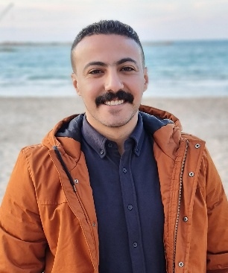

Mohamed

Hanafy mohamed elmaghraby

***Personal Information***

**Address** : Building no. 36 Tarek st. Sedi Gaber – Alexandria -Egypt

**Mobile no**. : +201016630888

**E-mail** : M.ElMagraby888.Gmail.com

**Date of Birth** : January 14 ,1992

**Marital Status** : Married

**Military Service** : Accommodated

**Nationality** : Egyptian

***Skills Summary***

* **Obtain a suitable job that enables me to utilize my computer, communication, language skills, marketing and sales representatives which will fulfill my personal ambitions and enhance my knowledge.**

***\*Trade Marketing & Distribution Rep***

***• Achieve trade coverage, visit frequency and outlet***

***visit plan in order to maximize route effectiveness***

***and efficiency.***

***• Ensure that the territory volume and distribution***

***objectives of company brands are achieved by trade***

***channel and outlet type in order that availability is***

***maximized in line with brand strategies and the needs***

***of the market.***

***• Ensure optimal stock levels, product quality and***

***freshness through stock management, orientation to***

***the trade and reporting on supply chain and product***

***issues.***

***Ensure that price is in line with the company***

***strategy***

***• Gain customer participation in Trade and Consumer***

***promotions, placement of merchandising materials,***

***optimization of product positioning and impact "face***

***on” display in line with the company's space***

***pangrams in order to maximize brand awareness and***

***visibility***

***• Provide support to the trade through regular and***

***accurate communication, problem solving,***

***specialized advice and fair trade.***

***• Maintain accurate and relevant outlet information.***

***• Implement the account plans for merchandising***

***and promotion through support of Part-timers in***

***order to achieve distribution and visibility targets***

***(where applicable)***

***· Co-ordinate Part-timers/Merchandisers in order that***

***trade marketing representation in retail chain outlets***

***is superior to the competition in respect of both core***

***and added value services (where applicable).***

***• Manage financial accounts and assets for the***

***territory to ensure that trade marketing resources are***

***secure and used in the most efficient and effective***

***manner possible.***

***• To constantly monitor the achievement of yearly/***

***cycle objectives through accurate reporting and***

***feedback.***

***• To provide market information and reports to ensure***

***that the relevant marketing people are fully informed***

***at all times.***

# Education

B.A of Greek and Roman archaeology faculty of arts

## Date of graduation

August 2015

# Experience

**August 2013 - September 2014** :

-Marketing at Field Action for advertising co.

Trained 2 months on marketing and office procedures at Vodafone .

Worked as a **brand ambassador** at **Field Action** for advertising co. with:

* CRAFT co.
* Cocacola co.
* L'ORÉAL ELVIVE
* Ülker
* Betty crocker

**January 2018 - December 2018** :

-Marketing at JT International.

**January 2019 – November 2019**:

-sales representative at JT International.

**September 2020 _ March 2022 :**

-Direct sales at Mansour international .

**April 2022 _ May 2022 :**

-sales coordinator at Geidea.

## Academic Education

* Corporate culture and coaching program

*Commercial Diving

*Business English

*Business Writing

*Presentation Skills

*Computer Skills ( MS Office 2003 – MS project internet)

*Extra sessions for Accounting, Finance, Sales and Marketing

***Skills***

Excellent oral and writing communication skills in English and Arabic

MS Office 2016 including internet communication