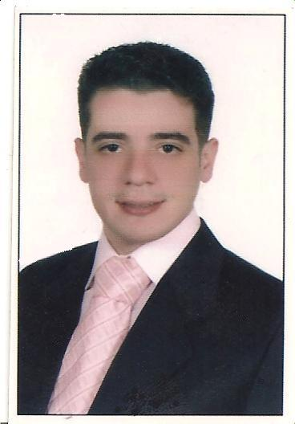
Karam Mahfouz Mustafa
Mobil: +0201115877579
E-Mail: kram.mahfouz@yahoo.com
OBJECTIVE
Aimed at the challenge of work and interaction with the environment, employment and access to achieve my ambitions at work and the flexibility it and communicate with all sectors related to the work as I can enter data for institutions and companies accounting for a finding of financial statements upon which the adopted financial decisions and to provide tax returns and reconciliations required of customers and suppliers and the various reports required
.
PERSONAL INFORMATION
Date of Birth: | April, 5th 1978
Gender: | Male
Marital Status: | Married
Nationality: | Egyptian
Religion  Address | Muslim  40 st Abed Al Hamid – Alhadaya- Alex-Egypt .
Driving license: | Valid Driving license
QUALIFICATION AWARDED
Tanta University, Faculty of Commerce , Egypt 2001 Accounting Division
LANGUAGES
Arabic: | Mother tongue.
English: | Very good reading, writing and listening.
SKILLS
Soft Skills:

Soft Skills: | - Very good deal with computer and internet.
Soft Skills: | - Very active , Fast learning ability, Stimulate hard work , Team Player
Soft Skills: | - Customer Service Care/Support Techniques.
Soft Skills: | - Business oriented with a positive attitude. Accept changes smoothly
Soft Skills: | - Very active , Fast learning ability, Stimulate hard work , Team Player
Soft Skills: | - Customer Service Care/Support Techniques.
Soft Skills: | - Business oriented with a positive attitude. Accept changes smoothly
Soft Skills: | - Very active , Fast learning ability, Stimulate hard work , Team Player
Soft Skills: | - Customer Service Care/Support Techniques.
Soft Skills: | - Business oriented with a positive attitude. Accept changes smoothly
Computer Skills: | - Windows operating systems (Windows 7, Windows Vista, Windows XP, Windows 98)
Computer Skills: | - Microsoft Office [97-win 10][Word – Excel – Access – PowerPoint – Outlook]  - Netscape 4.05+ Professional Edition & Internet explorer  - Ms Project 2000 and Oracle
Computer Skills: | - Very Good use of the internet and making researches.
WORKING EXPERIENCES
Financial manager in Romoz Al-Mazaya company from 1/12/2014 to 01/07/2019
- Accountant in Madinat El Oloom international school KSA From 14/3/2010 to 12/11/2014.
- Accountant in Majid Al-Kholi Foundation, King Abdullah st,Buraydah, Qassim , KSA P.O .Box: 30450,Qassim 115411, KSA tell:096606325311 from 21/01/2008to 14/03 /2010Qassim KSA
- Senior accountant of El Shraf for ceramic from 31/03/2005 to 30/12/2007 Alex Egypt
- Account in Arab Dray from 15/10/2001 to 18/02/2005 Alex Egypt
Courses
- Alexandria Electric city2002 for computer sciences
- ICC for technology
Business skills
I can enter data on institutions and accounting firms to conclude the financial statements underlying the financial decisions taken and to provide tax returns and reconciliations required of customers and suppliers and the various relationships required

Expected Salary

- Look for physical safety limit for my family, with an estimated five thousand and five hundred Saudi riyals per month ( 5500 SR)
- I hope also exchange tickets , medical insurance, housing allowance and annual allowance transmission Dealing with customer’s solutions
General Experience
Generally, I find myself in accounting and financial reporting and auditing various, dealing and communicating with different kinds of people,
It’s very challenging to have an upset client smiling at the end of the day. I enjoy PS. I have a worldwide passport and international driving license and ready.

All the resources under the request

It is my pleasure to join your teamwork

Financial auditor :
Karam Mahfouz

الســـــــيــرة الـــذاتــيــــة
البيانات الشخصية :-
الأسم : كرم محفوظ مصطفي
تاريخ الميلاد : 5 / 4 / 1978 م الجنسية: مصري
الديانة : مسـلم الحالة الإجتماعية : متزوج
العنوان : 40 شارع عبد الحميد – الهدايا – رمل الاسكندرية
المؤهل الدراسي / بكالريوس تجارة شعبة / محاسبـة سنة التخرج / 2000 ـ 2001 م
المهارات الخاصة :ـ
حاصل علي دورات مجمعة ببرامج :
مجموعة الأوفيس { ور د اكسل اكسس بور بوينت } اوتو كات اكاد سي فوتو شوب
انتر نت اكسبلولر نت اسكيب و اوراكل حاصل علي دورات صيانة تجميع الحاسب الآلى
اجادة الغة الأنجليزية كتابة وتحدث
العمل الحالي :-
مدير مالي بشركة رموز المزايا التجارية بالمملكة السعودية من تاريخ 1/12/2014 م و حتى 01/07/2019 م
الخبرات السابقة :ـ
محاسب عام بمدرسة مدينة العلوم العالمية بالرياض بالمملكة العربية السعودية من تاريخ 14/ 03/ 2010 م إلى 12/11/2014.
محاسب بمؤسسة ماجد الخولي للمقاولات بالمللكة السعودية من تاريخ 8/ 2 / 2008 م الى 10/03/2010 م .
العمل بشركة الشرف للسيراميك من الفترة 31 /3 /2005 م الي 30 / 12 /2007 م
العمل بشركة عرب ديري للتجارة من الفترة10 /10/2001 م الي 18 / 02 / 2005 م
201115877579 + للاتصال :- جوال :
E- Mail: kram.mahfouz@yahoo.com
تفضلو بقبول فائق الإحترام
أ / كرم محفوظ

