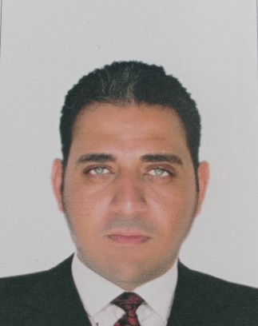

**Mina Gadelkarim Essa**

***Personal details:***

* **Date of Birth**: 1/2/1986.
* **Military Status**: Exemption.
* **Nationality**: Egyptian.
* **Place of birth**: Cairo.
* **Address**: 25 Theabet Street – Helwan, Cairo, Egypt.
* **Mobile Phone**: 01276506274.
* **Marital status**: Married.
* **Passport**: Valid.
* **E-mail**: **MINA.GAD@WADIDEGLA.COM**

**Education:**

B.SC. Of Computer Science-ELGezeera institute

Graduation: fair

Data of Graduation: 2007

**Language:**

* Arabic: Native Language.
* English: Good.

**Computer Skills:**

* All Microsoft Windows
* Microsoft office (Word - Excel) 2013
* Emails & surfing the internet & making researches.

***Personal Skills:***

* Handling Complaints.
* Work under pressure.
* Work inside and outside the country.
* Problem Solving.
* Motivating Others.

***Highlight Of Qualification:***

* Ability to produce high-quality work under pressure.
* Visibility of work requires, and attention to detail.
* Ability to adapt to changing business needs by continuous.
* Effective time management and organizational skills

***Professional Experience:***

* Work in the field of contracting and construction in Kuwait ( 2009 ).
* Working in Wadi Degla Club from 2010 till now.
* Work in the Department of the school ball (Arsenal) As an administrative officer and the task of sending Reports to Captain / Nader Shawki ( 2010 - 2014 ).
* Working as an employee in Wadi Degla as an administrative employee As an administrative officer and the task of sending Reports to MS. Amira (2014 - 2017 ).
* I am currently working in the financial department as a data entry since 2017 until now and the task of sending Reports to Mr. Ahmed Abdelfattah .

***Thanks for your Kind Attention to the contents of my C.V.***

***And hope it will meet your Requirements.***

***Best regards.***