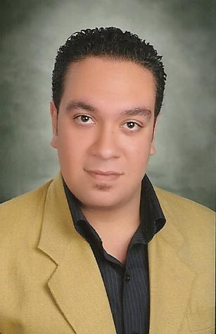Kamel Shawky Kamel

**23 Mesahel street .Mina EL- basal .Alexandria. Egypt**

**Home Telephone: 00203-445-2234**

**Cell phone: 0020114-594-8839**

**E-mail:** [**kamel_sh82@yahoo.com**](mailto:kamel_sh82@yahoo.com)

**Personal Information:**

**. Nationality: Egyptian**

**. Date of Birth: 19/02/1982**

**. Marital Status : Single**

**. Military Status : postpond**

**Objective:**

**To get a starting position in one of the leading companies in The Textile Field**

**in Egypt as a Textile Engineer .**

**Education:**

**. B.Sc. of Textile Engineering, Alexandria University - 2011**

*.* ***Graduation Project:* the effect of modern draft systems on yarn Quality**

***Project grade:* Excellent *.***

**Training experience:**

**. Al-ameria Co Summer 2008**

**. Stia wool spinning&weaving Co Summer 2009**

**.Stia cotton Spinning&weaving Co Summer 2010**

**. Spinalex Co from Oct to Apr 2011**

**.Since june 2012 till now in CSA textile Egypt as a production engineer**

**Languages:**

**. Arabic: Native language**

**. English: Very good (listening and reading) ,**

**Very good (writing and speaking)**

**Computer skills:**

**.Microsoft office .Internet**

**Other activates:**

**. Owner of a garment press for about 7 years. This gave me wider contact with many factories in garment manufacturing field**

**Skills :**

**.can work under pressure.**

**.Have the leadership.**

**.Having team spirit.**

**.Perseverance.**

**.Have the willingness to take calculated risks.**

**.Can makes quick decisions.**

**. Dynamic, hard workers and self motivated.**

**Hobbies:**

**. Listening to Music**

**. Fishing**

**. Practice Sports**

**. Travelling**

**. Internet**

**References:**

**.Prof.Dr/ Rafat Ibrahim Mashaly . Alexandria university vise president before ,Tel 01005463140**

**.Prof.Dr/ Aida Shetta. Alexandria university vise president before ,Tel 01064425575**