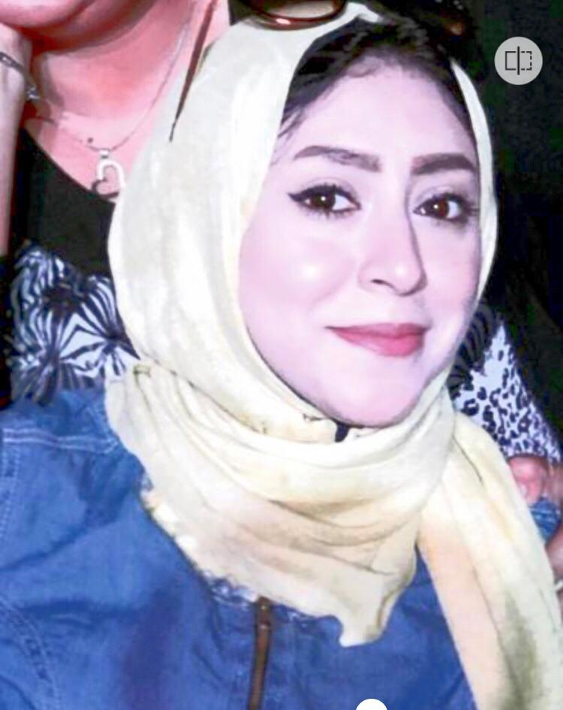
Aya Talaat Saad yoyootalat@icloud.com

Objective

To join reputable firm that will help me advance in my career in tourism & hotel sales, and operational management.

Personal data

Name: Aya Talaat.
Date of birth: 04th – June – 1992.
Marital status: Single.
Nationality: Egyptian.
Address: 3 Reda St. 9 Street , Hadayak El Maadi, Cairo.
Tel: 01116009587 (Egypt)

Education

- Faculty Of Social Work Helwan University
- Date of graduation: 2013

Experiences.

Aug 2013 – Feb 2014: Social Worker In Girls Institute Of Maadi Azhary

Nov 2014 _ Sep 2017: Reservation Officer in Relgious Tourism, Egytrav Company

Sep 2017 – Till Now: Tour Operator , Egytrav Company
-Responsible for individual booking & tours inside & outside Egypt
-Handel medical conferences arrangements with key pharmaceutical companies
- Experience in tourism field inside Egypt Communication and negotiation with supplier, hotels to get best offer.

Skills and training received

Professional:

- Advanced professional communication skills.
- High impact communication skills.
- Reprints detailing and handling.
- Presentation skills.
Language:
Arabic: mother tongue.
English: Good .

IT-Literacy:

- Well aware of PC. And networking.
- Professional use of Office programs (Word, Excel and Power Point.)
- Skilled in Internet search and browsing.

Personal:
- Self-motivated, high self-confidence, results and sales oriented.
- Highly responsible.

Interests

- Reading.
- Music.

