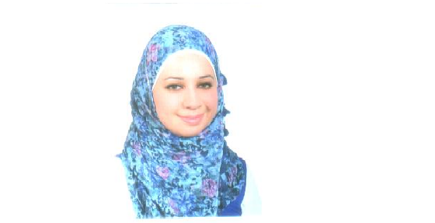

E-mail: [narmeen.aburub@gmail.com](mailto:narmeen.aburub@gmail.com) Amman – Jordan (0795535306)

**Nirmeen Mohammad Abu Al rob.**

**Date of Birth 28/8/1986**

**Nationality Jordanian.**

**Marital Status** **single**

**Objective** To be **one of our team in organization**

**Experience : (20/1/2009 –1/4/2018) ( AL Saif Industrial company for Aluminium) (Amman - Al-Bayader)**

**. Executive secretary**

* **Calling the customers and deal with them .**
* **Printing & use Microsoft office and internrt .**
* **commercial correspondence**

**( 1/5/2018 - 1/9/2018) training on ornament in ( Traditional Islamic Book Arts )**

**Education 2005 – 2009 Islamic University of Science (Amman)**

**Bch. in Islamic traditional arts & Architecture**

* **With grade of good .**

**Skills : use Autocad programe .**

**Calligraphy art & Islamic ornament**

**References references are available on request**.

**Language :**

**Arabic : excellent ( mother tone ) .**

**English : good In reading & writing .**