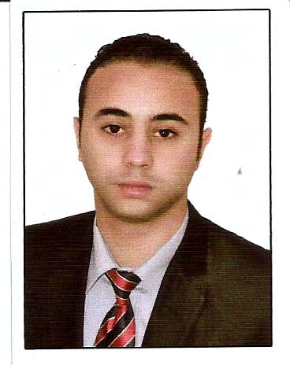

Curriculum Vitae

Name : MOHAMED YEHIA SAAD
Address : 31,Elfardos street, Seamoha, Alexandria, Egypt
Mobile : (s) +201211765915
E-mail : mo7ayaya2015@gmail.com
/ Mohamedyehia20102011@gmail.com
Nationality : Egyptian
Date & birth : 23/6/1990
Gender : Male

Employment / Occupational field:
Delegate Customs Ehassco company
Store manager in falky mall
administrative works in Porteland company
in Ramada hotel traner

Work experience: Customs clearance even out the goods from the port For example, timber and foodstuffs have worked out for 3 years

Educational Qualification: Bacalrios Travel & Hospitality Division (Tourist Studies) allocates booking tickets (Egoss)
Graduation Year : 2013

Languages: English (good)
Deutsch (good)

Computer experience: using the internet
Microsoft word
Hardware

Skills: Driving cars, swimming, horseback riding
team work and using the internet

Favorites: travel and tourism

