**Fady Antar Khalifa Abdel-maseh**

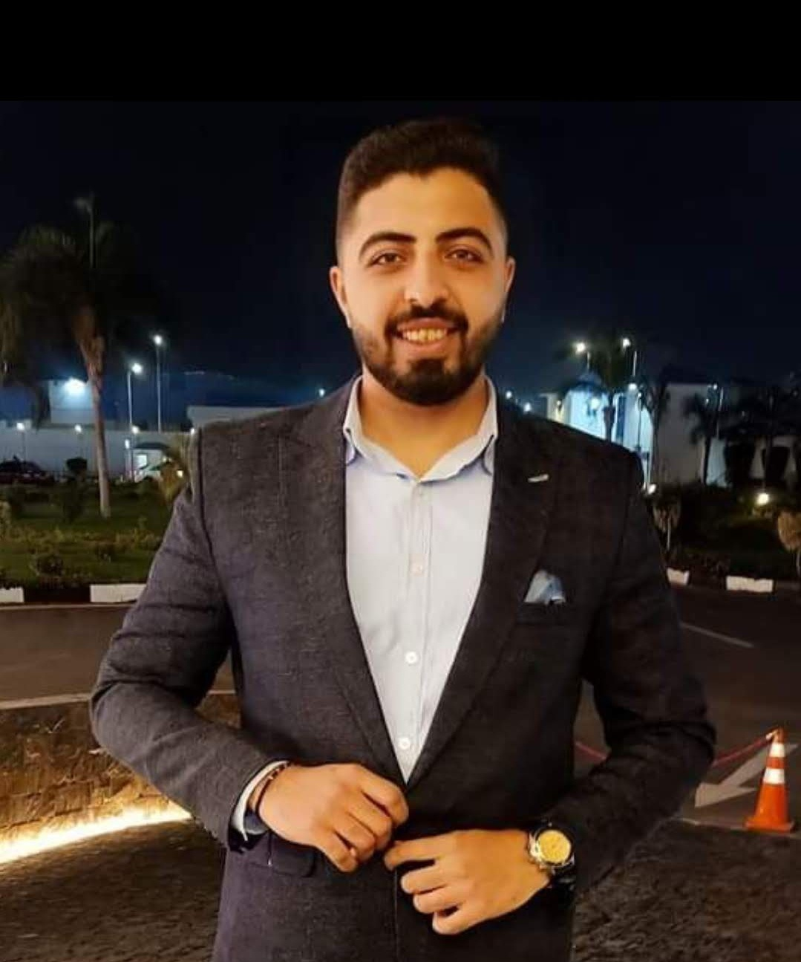

**1 / 11 / 1998**

**Shubra Elkhema , Cairo , Egypt**

**+201080378401 / +201277781949 |** [**fadyantar4321@gmail.com**](mailto:fadyantar4321@gmail.com)

**Objectives**

I'm a quick learner and aspire to work in an institution that promotes higher learning  
and skills enhancement, Excellent communication skills, Driven to succeed, and always early for every appointment .

**Educational Background**

**•** Bachelor’s degree at Business Administration – faculty of Commerce – Ain shams University  
( Oct.2018 – Oct. 2022 )

**Courses**

**•** Business Administration at E3mel Business Academy : ( Current )

**•** Digital Marketing at Hp life

**•** English Language course at The American University in Cairo "AUC"

**Work experience**

**•** Master Crafts for Marketing Solutions : ( Nov.2021 – Jun.2023 )

• Be Different for Marketing Service : ( Mar.2020 - Nov.2021 )

**Skills**

**- personal skills**

1- Teamwork

2- Communication skills

3- Problem solving

4- Time management

5- Influential leadership

6- Presentation skills

7- Public speaking skills

8- Negotiations

**- Computer skills**

1- Microsoft word excellent

2- PowerPoint very good

3- Microsoft Excel very good

4- Google Excel sheets very good

5- Photoshop very good

**- Language skills**

1- Arabic (native speaker)

2- English “written – spoken – reading” (A2 level)

**Certificates**

- Digital Marketing at Hp life

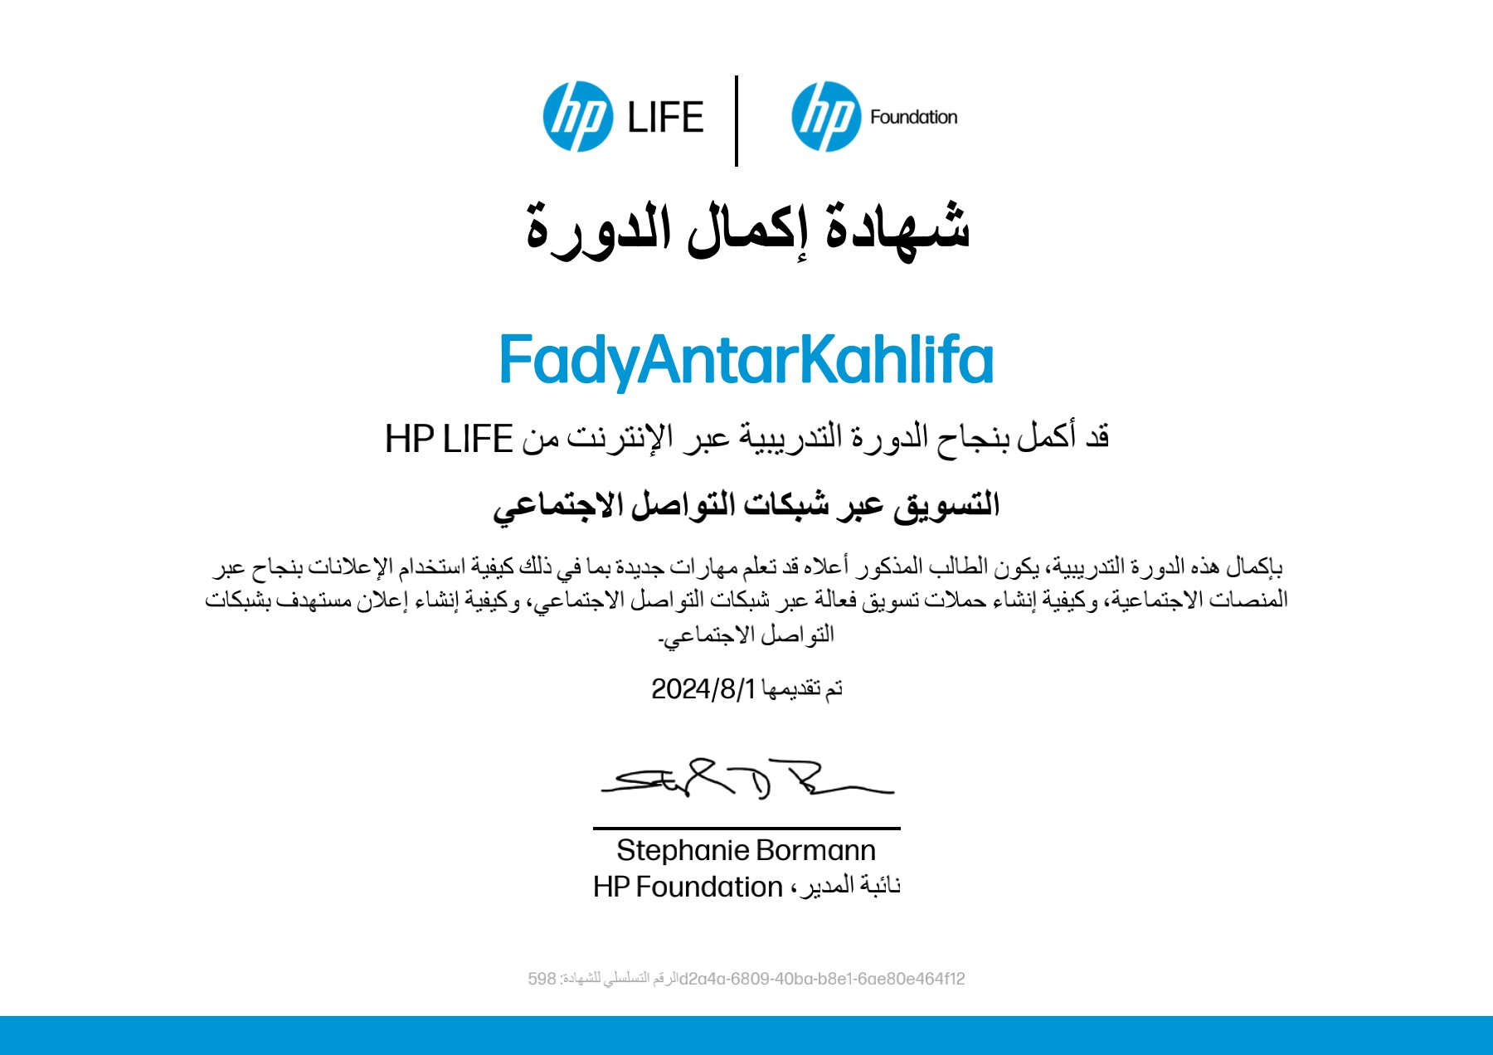

- English Language course at The American University in Cairo "AUC"

