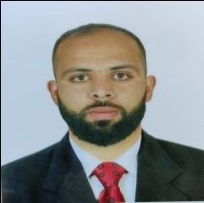

**No industry experience**

* Excellent academic training
* B ranking in the university course
* Having the spirit of working in a group and the sense of responsibility
* Accepts travel throughout the national territory
* Good physical condition
* Ability to adapt and integrate

**Languages**

**English: very good**

French: very good

Arabic: excellent

Sports, economy, foreign policy, project development

**Bara Seyfeddin**

**Areas of interest**

Setif - Algeria

**Tél**: 0672 06 32 22

**E-mail**: [saifbara13@gmail.com](mailto:saifbara13@gmail.com)

Residence address: Street 255, Ain El Hajar, Setif

family status :Unmarried

driving license :Lightweight

**FORMATION**

**Master Diploma**  Chemical Engineering **2020_2019**

**Setif-Algeria Ferhat Abbas**

**Bachelor's degree Diploma** **2018_2017**

**Setif-Algeria Ferhat Abbas**

**Software:** Word, Excel , Hysys , chemcade , power point ,Origine *,*

**My personal profile**

©AZURIUS –