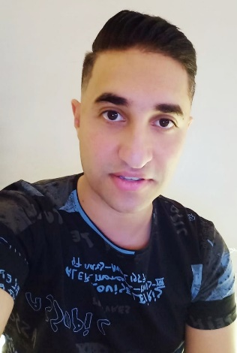

**Egyptian, 28 years old WhatsApp &Tel: 01093906989**

**E-mail:** [**amgadsalah2030@gmail.com**](mailto:amgadsalah2030@gmail.com)

**LinkedIn:** [**linkedin.com/ amgad**](http://www.linkedin.com/in/momen-fayez) **salah**

# EDUCATION

* Bachelor of Textile Engineering - Faculty of Engineering ـــ 2019
* **Grade**: very good
* HIET (Higher Institute for Engineering & Technologies)

# Graduation Project

* **Design and development flat knitting machine**

(As an educational model to explain the movements of the needles with the development of the method of movement of the needles)

* **Design flat knitting products (Pullover)**

# Experience Flashback

# Production coordinator

# Extremely organized, detailed, accurate business professional adept in prioritising work with The ability to manage multiple productions and implementations simultaneously

# Proven competencies in as an administrator with the skill to foster work environments

2019/ **the red mountain in Cairo**

* + I was commander in the armed forces Flags factory

## 2022/2023whiteflower

## Shift manager

* Main tasks:
  + Following up production prosses calculate production
  + Checking Quality Of Products
  + Machine maintenance training
  + Sample analysis training
  + Software of STOLL (M1) training
  + Leadership Through Quality

# Training and Courses

* + Oriental Weavers on the 10th of Ramadan corporate at the end of each academic year (2016-2017-2018)
  + Mac Carpet company – 10th of Ramadan
  + The Circular Textile factory in the industrial area of 10th of Ramadan

# LANGUAGES

* + English full professional

# AREAS OF EXPERTISE

* + Quality Control
  + Production Firm
  + Software of STOLL ( M1)
  + Machine maintenance
  + Yarn sample analysis

o production management

# Computer & Technical Skills

* + MS Office
  + AutoCAD
  + Photoshop
  + M1
  + Ned Graphic
  + Customer Relationship Management
  + Negotiations
  + Data entry
  + Achieve targets and work under pressure
  + Proactive and intuitive leader
  + Excellent communication skills

# Hobbies

* + Reading
  + Sports ( free running – Swimming )
  + Sketching
  + Design

**Certifications**

* Bachelor of Textile Engineering
* Experience certificate from the armed forces