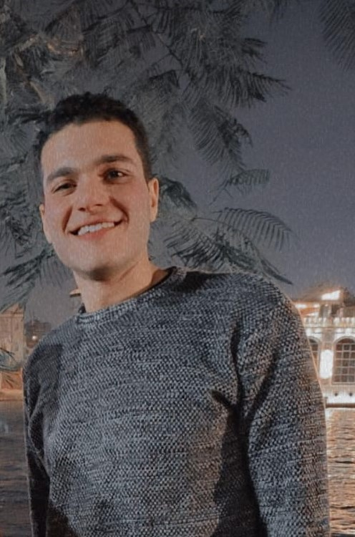 |  |  |  | Marwan  adel abib

Experience
2014–2016
pormoter• pormoter • infinix
2017–2019
senior• area en shams • sony
2019–2020
SENIOR• selse • sharmen Sharm El-Shaikh
2020-2022
Branch Manager..2B..NASR CITY
Currently I am working in 2B
I moved to the service center department and I am responsible for the rma department

Education
law, helwan
- Helwan university faculty of law
Profile
I am 27 years old, a graduate of the Faculty of Law, Helwan University. I worked in the field of sales for 9 years in the field of furniture and real estate.
I can write in word excel
Currently, I work in 2B in the service center department

References
English GOD
WORD VIRY GOD
EXCEL VIRY GOD
human development
ش122 مشيه السد العالي خلف حديقه بدر جسر السويس
Egypt-ciaro
 |  | 01149389007/01018837319
 |  | adelmarwan176@gmail.com
 |  | [Your Website]

