Magdy Gomaa

21 Orchard Road Imbaba

magdy.gomaa98814@gmail.com

01114042382

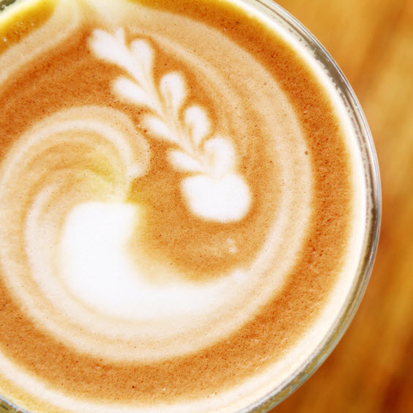

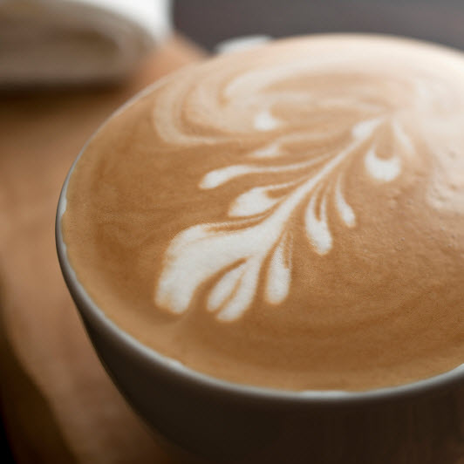

Magdy Gomaa

21 Orchard Road Imbaba

magdy.gomaa98814@gmail.com

01114042382

# Career Overview

Diligent in work and serious and also fun, Dealing with the problems and simply localized and try to solve them, God willing, Easy to talk to and approachable, I quickly develop an ongoing rapport with customers, and this is easily noticeable within the workplace. I am confident, skilled and enjoy being part of the coffee industry.

# Personal Information:-

## Name : magdy Gomaa Ahmed

## Date of Birth: 18/3/1985

## Position recruitment: Military service (good manners)

## Qualification: Industrial Technical Institute (above average)

## Mobile: 01114042382

## Marital Status: married

## Religion: Muslim

## E-mail: [magdy.gomaa98814@gmail.com](mailto:magdy.gomaa98814@gmail.com)

# Skills Summary:-

* **Certified Barista.**
* **Latte Art.**
* **Fudge Art.**
* **Working on Variety of espresso machines.**
* **Applying Customer Service Standards.**
* **Product Management Skills.**
* **Cash Handling.**
* **Bookkeeping.**
* **Well Speaking English.**
* **MS Excel.**
* **MS Word 2007.**
* **HTML.**
* **Familiar with many store POS system.**
* **Enjoy working in a team.**
* **Ability rapid absorption.**
* **Work under pressure for long periods**
* **Self-Education for new strategies and techniques.**

# Working TimeLine

* **From May 2018 until now store manager at Dunkin Donuts Mall of Arabia.**
* **from march 2015 until April 2018 : shift supervisor at Starbucks** **coffee**
* **From April 2013 until Feb 2015 Barista and Waiter at Cafe Cilantro Zamalek branch.**
* **From Dec 2012 until April 2013:** **Barista and Cashier at Paradise Company and Restaurant Panini Zamalek.**
* **From Feb 2009 until Dec 2012: Head Barista at Spectra restaurant.**
* **From Feb 2006 until Feb 2009: Responsible for the Employees’ hospitality affairs in the administrative affairs department in SW company.**
* **From Jan 2003 until Jan 2004: Barista at Fishing Club in Dokki.**
* **From Jan 2002 until Jan 2003: Assistant Chef in *Cafe Sacker* restaurant – Mohandseen.**