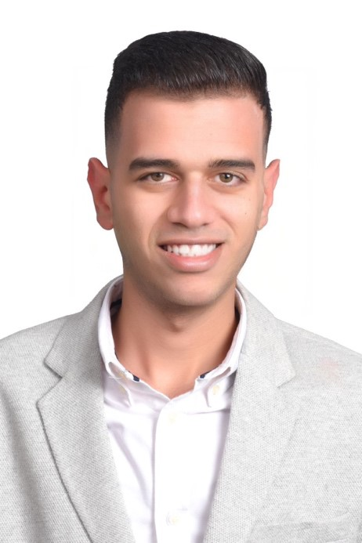

MOHHMED

GAMAL

**Date Of Birth: 15\09\1998.**

# HAMADATRIPLEH@YAHOO.C OM

TEL: +201010309444

ADRESS: SHAR EL ASAL , ALBISATSH , ALEXANDRIA.

# **Experience**

**Sales in** **Electronics shop (2019**). Selling products and services using solid

arguments to

prospective customers

**Sales in Mamo kids toys group (*2020***). Assist customers in locating toys of their choice.

Ensure customer satisfaction through sales function.

**Administrative Employee At  
 Art Link printing  
 ( 2020 *to present).***

Giving approval of the final print job. Overseeing quality control for the final product.

Managing the overall operation.

**1**

**SKILLS**

* Strategic thinking.
* Able to work in a team.
* Hard Worker.
* Able to solve Problem
* Spatial Orientation.
* Dynamic Strength.
* Able to remain calm emergency situation
* Knowledge of safety first aid.

* **Bachelor’s degree From Institute of Social Service**
* ICDL course with international license.

## LANGUAGE, COMPUTER PROFICIENCY

* Arabic: Mother Tongue.
* English: very good .
* Good command of Win, Word, Excel,
* PowerPoint, Internet and Network.

**2**