## Curriculum Vitae

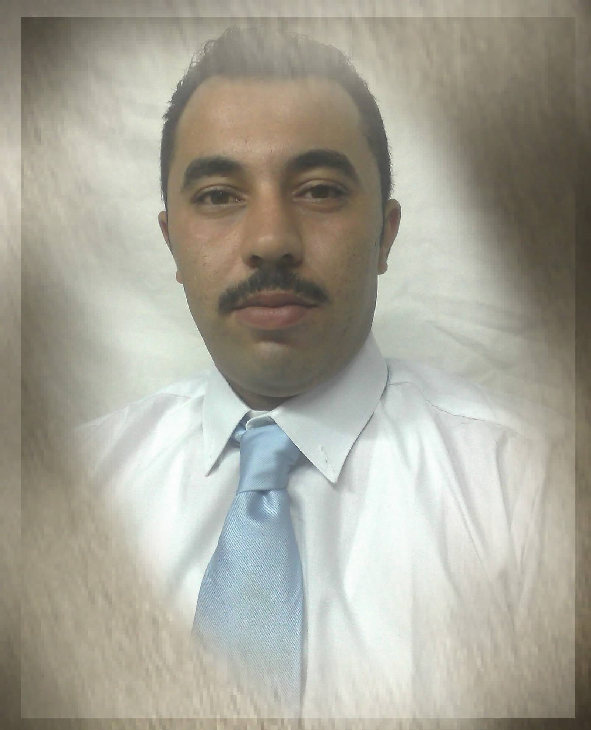

## 

## 

## Personal data:

## 

## ∙ Name : Salah Said Othman

## ∙ Date of birth : 2/11 / 1984.

## Marital Status : Married with two kids

## ∙ Mobile number: - 0100 4049363

## ∙ E-mail : Salahothman877@gmail.com

## 

## ∙ Address : M/Naser – Awlad Saqr -Sharqia

## 

## 

## Education:

## Technical diploma from Kafr Saqr Technical school 2000/2001

## 

## Languages:

## 

## ∙ Arabic Mother Language.

## 

## ∙ English Fair speaking & writing

## 

## 

## Experience:

## I am currently working at the Smash Club inEl-Sheikh, Sheikh Zayed, Cairo, as the director of cleaning period from October 2017 till now

## Worked at Al Diar Club in the fifth assembly as the director of the cleaning department from January 2015 to October 2017

## Sharm Plaza Hotel and Resort Sharm El Sheikh from September 2009 till Now as Housekeeping senior supervisor.

## 

## Grand Plaza Hotel and Resort Sharm El Sheikh from September 2006 till July 2009 as

## Housekeeping supervisor.

## 

## Laguna vista Hotel and Resort Sharm El Sheikh from April 2004 till June 2006 as

## Housekeeping Room Attendant

## 

## Queen Sharm Hotel Sharm El Sheikh from 2002 to 2003 as

## Housekeeping Room Attendant

## 

## 

## 

## 