**Awaz Abdulrahman Shekho Issa**

Iraq/ Duhok/ War City.

Tel: **+964 750 815 8588**

E-mail: awazissa@gmail.com

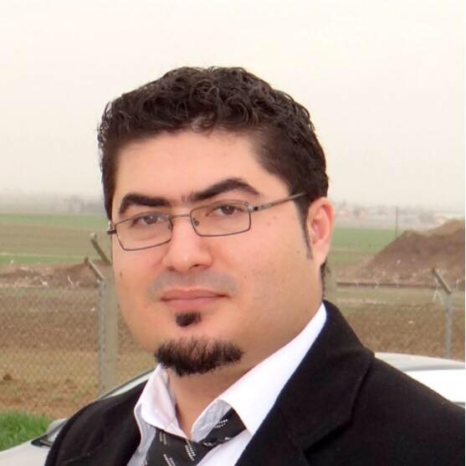

**PERSONAL INFORMATION:**

* Date of birth: 23/Dec/1984
* Place of birth: Al-Qamishli, Syria.
* Gender: Male
* Marital status: Married

**EDUCATION:**

* **University of Duhok, College of Administration, business management department 2006-2010**

**EXPERIENCE:**

* Worked as a machine technical at dar alArabya press in Lebanon 2001-2005.
* Worked as a machine technical at Khane press 2005-2006.
* Managing own business ( makeup shop) in panorama center in Duhok 2006-2007.
* Worked as a preseller in Coca Cola company in Duhok 2009-2013
* Promoted to SD(Sales Developer)at Coca cola company in Duhok 2013-2016 .
* Joined to Delta Korek company as supervisor in Duhok 1-8-2016 / 1- 4 -2017.
* Worked with Ulker company as marketing sales supervisor for Duhok government from 01- 04 -2017 _ 30-04-2022.

**LANGUAGE:**

Fluent reading, writing and speaking:

* Kurdish – Arabic – English

**COMPUTER KNOWLEDGE:**

* Microsoft Word, Excel, PowerPoint, Outlook, Internet tasks.

**Skills:**

* Data base analyzer & manager
* Team worker
* Double checking work quality
* Respecting Team Structure
* Very good communication and convincing skills
* Flexible, Honest, good listener
* Can work in difficult conditions
* Respecting local customs and sensitivities
* Able to improve his skills under line manager’s constructions
* Always on time
* Good relationship with Duhok authorities
* Expert in Duhok markets area
* Excellent experience and education background in sales
* Excellent experience in reporting mechanisms
* Able to drive and own a license from Duhok