AHMED RAMDAN ALI
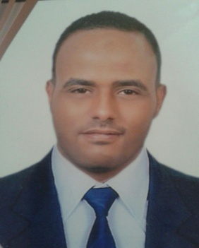
Ahmedramdan.abdo@gmail.com
+971567658500
Dubai, UAE
SUMMARY
Motivated skilled team player with extensive experience in waiter, sales, customer service, and Electrician .Flexible, good planner, Searching for an opportunity offering growth and advancement based on individual merit and capability. My background reflects extensive successful experience within the firm and I would like to utilize that experience in a position at your company.
EXPERIENCE
ELECTRICIAN & Storekeeper :  Electrician connections at TRUST BUILDERS for Construction ( Egypt ) |  | MAY 2010–AUG 2016
SALES MAN :  FATHALLAH MARKET For food products ( Egypt ) |  | JAN 2007 – DEC 2009
WAITER :
SANTOS Resturant and cafe in ALEX ( Egypt ) FEB 2004 – DEC 2006
PROFESSIONNAL CERTIFICATES
- Diploma At Electricity technician at electricity connections at Alex, Egypt

EDUCATION
Electricity prepare professional diploma  AL SHATBY secondary industrial, mechanical At ALEX (Egypt) |  |  | MAY 2004
LANGUAGES
Arabic: | Native
English: | Professional working proficiency
COMPUTER SKILLS
- MS Office; Word, Excel, PowerPoint
- Internet applications

COMMUNICATION SKILLS
- Able to work independently, manage time and work under pressure.
- Have administrative and organizational skills.
- Permanent desire to improve and to follow up developments of work.

PERSONAL
Nationality: | Egyptian
Birth Date: | 24/08/1984
Marital Status: | Single
References Available Upon Request

