ABD_ELGHANY FATHY IBRAHIM HAMODA
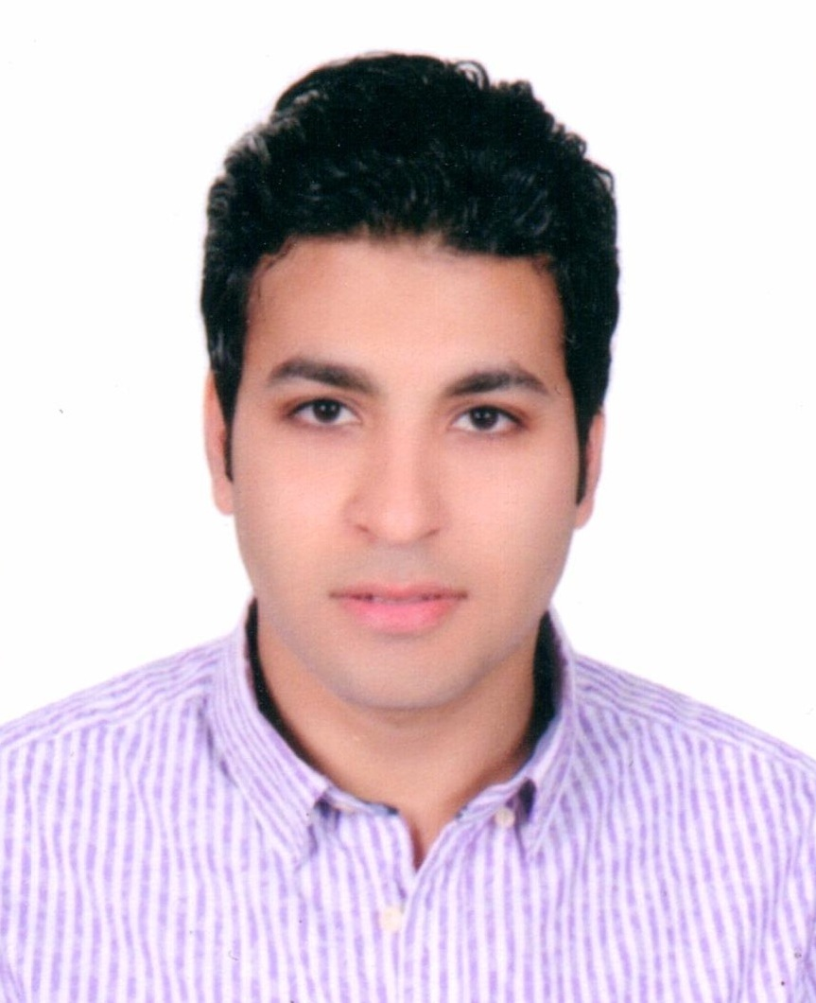
B.Sc.
Faculty of Commerce – Accountant
St10 *NOKRASHY - HADAYEK EL_ KOPPA - EGYPT
Mobile: 002-(0127)5563103
E-mail:account_abdo2010@yahoo.com

OBJECTIVE
Seeking a challenging career opportunity in a reputed academic institution where my skills can be applied and further developed. I believe that I will be able to add value to this institution which I work for, through my technical knowledge gained at university, my back ground, my experience and my interpersonal skills.

EDUCATION
B.Sc. of commerce & Department of Accounting, Benha University, 2007

Graduation project: The development of accounting in companies

LANGUAGE SKILLS
- Native language Arabic.
- Good command of both written and spoken English.
COMPUTER SKILLS
- Basic Computer Skills: International Institute for Languages ​​and
Computer (word – Excel – PowerPoint – Access-internet)

SOFT SKILLS
- The ability to learn new tools.
- Communication skills & Problem solving & Decision making.
- Presentation skills & Technical writing.
- Project management & Team leader.

Training course
- peach tree Form Egyptian Academy training of accountants
- excel Accounting Form Egyptian Academy training of accountants
- Financial analysis Form Egyptian Academy training of accountants
- International Electronic Accounting course from
- VAN HOLLAND UNIVERSITY IN HOLLANDA
- Manual accounting Form Egyptian Academy training of accountants

WORK EXPERIENCE

- Work in "EAST ASIA FOR COMPUTER SYSTEM COMPANY "since 8/2009until now as accountantThen, after 4 years,
- an account manager

- Work in "Islamic Paper Manufacturing Company" from 7/2008 to 8/2009 as a Storekeeper.

- Worked in "Queen Company for Food Industries" from 7/2007 to 1/2008 as accountant.

ACCOUNTING EARNED SKILLS

1 - Proof of accounting operations constraints in the general journal , general ledger and deportation to analytical notebooks and ledgers assistant and as stated accounting system applied to the institution .
2 - Compilation of general journal , general ledger and books a month with a view to preparing analytical balances and to ensure their validity to reach the business results and financial position of the institution.
3 - Matching cash held by the Treasurer with the installer books a day.
4 - At the end of each month the audit and matching between bank accounts balances with the payroll records of these banks accounts and make the necessary adjustments.
5 - Preparation of monthly accounts statements sent to both customers and suppliers and Gary associated companies for the purpose of emphasis on the safety and health of the balances of these accounts and make the necessary adjustments if any differences.
6 - Follow - up to the collection of dues to the institution customers and extract a statement customer balances accumulated stalled for payment submitted to the President or accounts administrator for review and submission to the Chief Financial Officer.
7 - Prepare salaries and review and presented to the Chief Financial Officer for approval.
8 - What cost of other work in the area of ​​jurisdiction.
HOBBIES & INTERESTS
- Reading, Internet, Football, Swimming, Traveling.
PERSONAL DATA
.
- Date Of Birth : 8 Jan, 1986
- Marital stats: Single.
- Military status: Exempted..

References are available upon request.

