Personal Information
Name |  | : Mohamed Yousry Hamed Hanafe
Nationality |  | : Egyptian
Date of Birth |  | : 13/9/1988
Place of Birth |  | : Giza
Marital Status |  | : Single 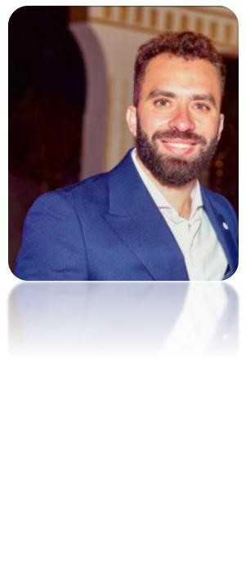
Military Status |  | : ِExempted
Contact Details
Address | : EL Sheikh Zayed - Giza , Egypt
Mobile | : 01119994779
E-mail | : Mo.yousryhamed@gmail.com
Education
Bachelor of Commerce - Business Administration, Ain Shams University
Graduation Year: 2011
Accumulative Grade: Good
Languages
Arabic | : Mother language
English | : Well
Computer Skills
- Adobe After Effects - Photoshop - Illustrator
- Microsoft Office (Word & Excel & Powerpoint)

Work Experience
- Senior Operation Manager at Compound Al Guezira Club House - Giza , Egypt.
From 2013 to Now
Duties include:
- Solving customer problems.
- Management team work.
- Completion of new contracts for sports activity.
- Perform customers public relations for different events.
- Contributed to new ideas that led to major expansions in the club.
- Participated in developing marketing and advertising plans for the club.
- Full coordination between club members and management.
- Supervision of maintenance work.
- Organizing staff appointments.
- Supervision of maintenance work.
- Set club subscription price plans.
- Supervision of the security company and the company of cleanliness, and follow-up workflow.
- Able to give and receive constructive criticism.
- Attention to detail, adaptability, flexibility, communication skills, teamwork.
- Designing events advertising brochures and banners.
- Operation Manager at Compound El Karma Club - Giza , Egypt.
From 2010 to 2013
Duties include:
- Handle club clients and reception tasks.
- Perform customers public relations for different events.
- Designing events advertising brochures and banners.

Training & Courses
- Graphic Design Course from the Russian Cultural Center.
(Adobe After Effects & Photoshop & illustrator & InDesign) - Certificate in Soft Skills from DHL Company.
- Certificate in Human Resources from DHL Company.
- A training course in the art of preparing leaders.
- Certificate in ICDL from Ain Shams University.
- Training in Shell Egypt.
- English Course from Ministry of Tourism.
- Training Course at Human Rights - Field Training from Cairo University.
- Training Course at Human Resource Development from Cairo University.

Hobbies
- Reading.
- Travelling.

Sports
- Football.
- Swimming.
- Diving.

