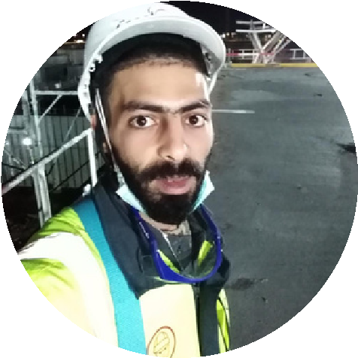

**ABDELKRIM ECHCHORFI**

ELECTRICIAN MAINTENANCE

**PROFESSIONAL**

**PROFILE**

I am a master electrician with

more than 5 years of training,

and I can install and maintain

electrical equipment and wiring

systems efficiencies.

**CONTACT INFO**

E

mail: charfiabedkrim@gmail.com

Phone: (+253) 77 09 99 58

Address: FEPCO Airport, Djibouti

**KEY COMPETENCIES**

E

lectrical System Installation

and Maintenance

Electrical System Inspection

and Testing

Troubleshooting of Electrical

Circuits

Control Panel Wiring

Reading electric schema

Laying electrical cords

according to designs

Designing electrical paths as

per designs required by site

schema

lights Repairing

**CAREER SUMMARY**

Building electrician | 2017 - 2018

Building electrician | 2016 - 2017

NAROVA

CEGELEC

**PREVIOUS EDUCATION**

Qualification diploma | Sept 2014 - Jul 2016

High School Degree | Sept 2013 - June 2014

INSTITUTE OF APPLIED TECHNOLOGY HAY

MOHAMMADI, CASABLANCA

MOHAMMED SIX

Electricity Industrial Maintenance Division

Literary major

PLASTIMA

Building electrician Maintenance | 2018 - 2019

PLASTIMA

Building electrician Maintenance | 2018 - 2019

SOGEA MAROC

Electrician Maintenance | 2019 - 2020

FEPCO AIRPORT DJIBOUTI

Electrician Maintenance | 2020- present