**CV**



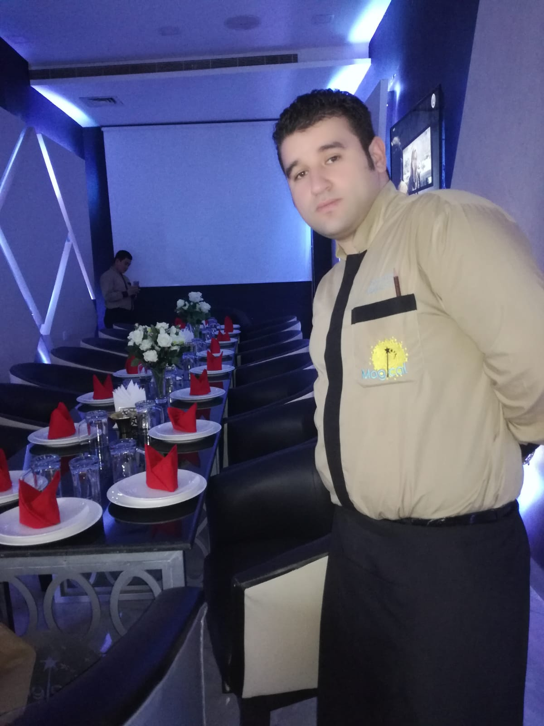

**CV**

**FARES**

**SFAR**

Experienced Waiter

**DIPLOMAS Y HOBBIES**

**Formaciones :** Diplomados, Congresos, xxxxxxxxxxxxxxxxxxxxxxxxxxxxxxxxxxxxxxxxxx

**Hobbies:**xxxxxxxxxxxxxxxxxxxxxxxxxxxxxx





Mahdia tunisia

21656345021

sfar.feress2022@gmail.com

***ABOUT ME***

Experienced waiter with excellent customer service skills. Responsible for taking orders and serving food and beverages to guests. They play an important role in guest satisfaction as they are also responsible for checking on customers to ensure that they are enjoying their meals and take action to correct any problems

**SOFTWARE**

Excel

PowerPoint

Word

**Education**

**SKILLS**

**7th year primary**

**Mahdia Ezahra School**

* Point-of-sale systems
* Food safety
* Effective communication
* Active listening
* Positive language
* Problem solving
* Patience
* Resilience
* Social perceptiveness

**PROFESSIONAL EXPERIENCE**

* Driving light tourist cars.
* Driving transport trucks of all kinds.

**Personal skills**

Arabic

Frensh

English

**LANGUAGES**

**GRAND HAYAT**

**WAITER**

**Completed tasks:**

* Greet and escort customers to their tables
* Present menu and provide detailed information when asked
* Offer menu recommendations upon request
* Take accurate food and drinks orders, using a POS ordering software,order  slips or by memorization
* Check customers’ IDs to ensure they meet minimum age requirements for consumption of alcoholic beverages
* Communicate order details to the Kitchen Staff
* Serve food and drink orders
* Arrange table settings and maintain a tidy dining area
* Deliver checks and collect bill payments
* Provide excellent customer service to guests

**MGICAL**

**WAITER**

**Completed tasks:**:

* Greeting guests and taking drink and food orders
* Staying attentive to the needs of guests in the dining area
* Delivering food from the kitchen to the guests
* Keep tables clean and tidy at all times
* Check products for quality
* Deliver checks and collect payments
* Cooperate and communicate with all serving and kitchen staff

**2011/2013**

**(QATAR)**

**20215/2017 (saudi** **arabia)**