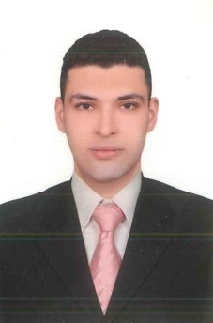

**Abd Elrahman Mohamed Anwer Afify**

**Damanhur**

**Address**

**Exemption**

**Military service**

**Phone**

**01148425747**

**Single**

**Marital Status**

**Email**

**Experience**

* **Bachelor of Sharia and Law, Law Division**
* **2019**

**Education**

**afifyabdoh2014@gmail.com**

* **Sales at PharmaOverseas**

**(25/7/2019 : 26/1/2021)**

* **Sales at AMECO Pharma Ceutical**

**(4/4/2021 : 7/12/2021)**

**Personal Skills**

**Obtaining a job opportunity in a professional work environment in order to continue developing my practical and scientific skills and to contribute to achieving success for the facility in which I work by achieving the tasks assigned to it in pursuit of the interest of the business.**

**Arabic: Mother tongue**

**English: Good**

**Languages**

**About me**

* **Excellent experience and skill in customer service.**
* **Proficiency in dealing with the computer.**
* **Excellent experience and skill in administrative work**
* **Human resources and sales.**
* **I constantly strive to develop my abilities.**
* **I love commitment at work.**
* **Ability to work under pressure.**
* **The speed of education and adaptation to the work environment.**
* **Good appearance and tact of speech**