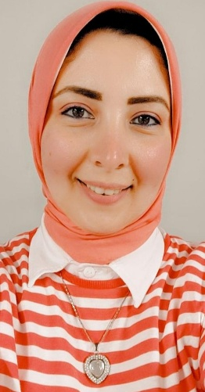**Nada Mohamed Mustafa Mustafa Wally**

**Address:**34 Hassan Assuem st – Gomrok -Alexandria

**Email:** noodii.94@gmail.com

**Mobile:** 00201200558139

* **Personal :**

Gender: Female

Date of birth: 17/7/1994

Place of Birth : Alexandria

Age: 28

Nationality: Egyptian

* **Education:**

‎-Bachelor of Commerce , Accounting Major 2016 , Good Grade , Alexandria University

* **Work experience:**

-Human resources , Payroll Accounting ,Social Insurance Accounts at Ibrahim Nada Hospital from October 2020 till now.( I have experience with dealing with the social insurance Office)

- Patients Accounts, Receptionist at Ibrahim Nada Hospital from August 2022 till now.

* **Skills:**

-Language Skills: Arabic (mother Tongue) - English

-Computer skills (word –PowerPoint - Excel - writing emails –writing research)

-Good presentations skills (have a gained through School activities)

-Good team participant: working and participant in team work through the previous School projects, assignments and daily tasks.

-Fast learner: I have ability to learn fast and work hard to gain experience and improve my skills.

* **Job Objective :**

-Working in a renowned, service oriented organization and healthy working environment in order to upgrade my skills and abilities acquired through education and experience.

* **Hobbies** :

-Traveling, Shopping, Baking, Learning and swimming