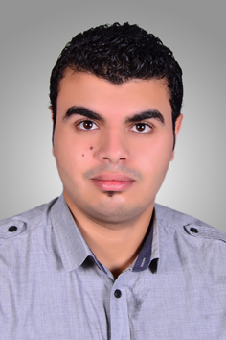

***Amr Mahmoud Saad Hussin***

El Souq Street

Khorshid, Alexandria, Egypt

Mobile: (+2)01211745562

Email: tamr74335@Gmail.com

***Summary of Qualifications:***

* Information Systems from the Pharos Advanced Systems Institute 2008.
* Certificates of Fire Warden Marshall Training from Enertech Qatar.
* Training Certificates from Aramex International Logistic.

***Work Experiences:***

* Worked as Supervisor of sales area (Alexandria) in El-Haramin Modern paints sale and collection with customers for 3 years .
* Worked as sales man in Qatar national printing press sale and collection with customers for 18 months “Doha Qatar”.
* Worked as purchases officer in Al-Baraa Construction purchase all company requirments and clear transactions for 1 year “Doha Qatar”.
* Worked as Sales and Collection Man in Al-Baraa Advertising sale and collection with customers for 1 year “Doha Qatar”.
* Worked as Sales and Collection Man in Al-Salem Steal and Aluminum sale and collection with customers for 2 years “Doha Qatar”.
* Worked as Data Entry in Logistics Department in Aramex International Logistic inbound & inventory & outbound for 30 months “Doha Qatar”.

Worked as sales man in El Arosa Tea sale and collection with customers for 15 months “Doha Qatar”

***Languages Skills:***

* Arabic: Mother Tongue.
* English: Good writing By Keyboard, speaking, and listening**.**

***Other Skills:***

* Good Communication & Presentation skills.
* Able to work in group, working under pressure, manage stresses, Helpful, creative, and calm.
* Analytical and logical problem solving and thinking.
* Strategic, focused and highly result oriented.
* Ability to meet deadlines successfully, maintaining the quality of work.
* Respond in positive manner to sensitive situations.
* Self motivated, good research abilities.
* Passion with a new technology.

i have driving license .

***Personal Data:***

* Date of Birth: 12th of August, 1989**.**
* Nationality: Egyptian.
* Military obligation: Permanent Exemption.
* Marital Status: Married**.**
* Gender: Male**.**

***References:***

* All references are available upon request.