-
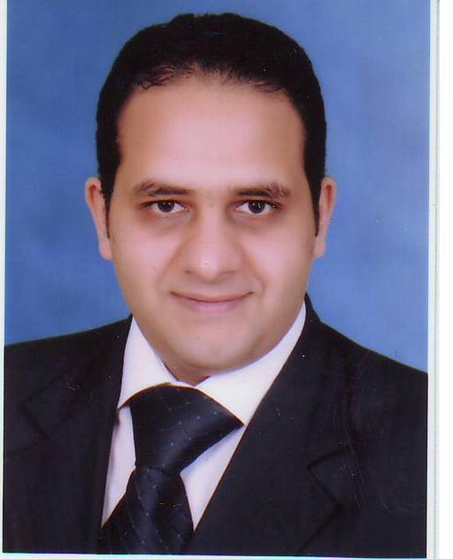
Mahmoud Salah
abd elmaksoud
Tower 2state cases Authority oasis Nasr Cairo Egypt
Phone :+201033733782
: + 201004078040
E-mail : eng.mahmoud22000@yahoo.com
Career Objective | Looking for the opportunities to learn more and more, gain experience, and improve my knowledge  Fields of interest :  Manufacturing and design, CNC, workshop technology, pump design and maintenance , welding, health and safety, water treatment and water planets ,solar energy, rabid prototyping and computer
Personal Information | - First Name: Mahmoud  - Last Name : Abd elmaksoud  - Marital status: Married  - Nationality: Egyptian  - Military Status: done with grad ( good example )  - Birth date: 25-05-1983 (dd-mm-yyyy)  - Place of Birth: Shubra, Cairo, Egypt  - Driving License: Available and Valid
Summary of Qualifications | 2007 Helwan University, Faculty of Engineering  Helwan, Cairo  Production Engineering  - B.SC in production Engineering, with fair excellent grade in the graduation project.
Graduation Project | Welding Inspection & Pollution Due to Welding
Practical Training | Local Training  From 06-15 -2004 to 6-29-2004  petrobel  - With experience certificate.  From 15-07-2004 to 15 -08-2004  mostrod water treatment station  - Water treating  From 06-02-2010 to 11-2-2010  - With experience certificate.  General Administration of civil protection  From 24-01-2010 to 27-01-2010  Red cross  - 3 days with experience certificate.  donposco institute  - 3 months A/C Course ( with certificate )  American university in Cairo (A.U.C.)  - Water planets design and operation (with certificate-excellent grade-).  - From 14-09-2013 to 21-12-2013
Languages
Languages | Language | Level
Languages | Arabic | (Mother Tongue)
Languages | English | V. Good
Languages | Germany | Fair
Computer Skills
Computer Skills | Software |  | Level
Computer Skills | Matlab 6.5 |  | V.Good
Computer Skills | AutoCAD |  | V.Good
Computer Skills | International Computer Driving License |  | _______

Work Experience | - le meridien pyramids hotel.  From 15-09-2008 to 01-07-2010 as a health and safety manager and fire officer.  - Appling Starwood standards for safety and fire safety and helping engineering department in maintenance plane .  - Dusit thani lakeview hotel.  From 01-07-2010 to 01-11-2011 as a health and safety manager and fire officer  - Appling dusit standards for safety and fire safety and helping engineering department in maintenance plane .  - Concorde Moreen beach .  From 05-01-2012 to 01-09-2012 as a Safety Engineer.  - Appling Concorde standards for safety and fire safety and helping engineering department in maintenance plane .  - Soul WATER FOR water treatment technology .  From 05-09-2012 till 01-02-2015 as a Mechanical Engineer.  - Arab organization for industrialization (A.R.E.C.o)  From 01-02-2015 till 01-12-2019 as a Mechanical Engineer in the Arab Renewable Energy Company works in solar Energy Design and quality and maintenance .  Designing and supervision of solar PV plants  Project supervisorand site manager at AOI ( A.R.E.C.O. ):  ▪ 1 Mega Gamasa land plant.  ▪ 400 kwAOI land plant.  ▪ 185 kw Cairo governorate administrative building.  ▪ 65 kw Alexandria governorate administrative building.  ▪ 150 kw Many presidency districts in Cairo.  ▪ 420 kw Companies of Electricity Distribution.  ▪ 20 kw The Egyptian Natural Gas Company(GASCO).  ▪ Installation, Operation and maintenance of more than 1200 solar lighting stand-alone poles. (At Aswan,ismaelia ,port saeed, Sharm el-sheikh alnasr street, 23 july axis, kastal land border and sharm el- sheikh airport s).  - self Imployed .  From 01-12-2019 till now as a Mechanical Engineer.

