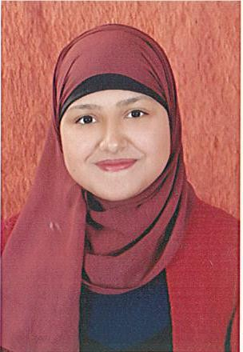

# PERSONL DATA

* Date of birth: 21-3-1994
* Gender : Female
* Nationality: Egyptian.
* Marital Status: Single
* Address: 11 Borg El Shorta , El Sayda Zainab , Cairo, Egypt.

# CONTACT

PHONE: (+2)01102817984

# EMAIL

[eman.sayed34@yahoo.com](mailto:eman.sayed34@yahoo.com)

# HOBBIES

Socializing -Community work and Volunteer Work Reading Traveling

Playing sport

**C.V**

Eman Sayed Ahmed Abd El Gawad

**WORK EXPERIENCE**

* **Company: union trading**

**Job title: secretary**

**Period : from September 2019 till now**

* **Company: Retaj School**

**Job title: Arabic teacher**

**Period : from April 2018 till may 2019**

* **Company: Tele performance.**

**Job Title : call center**

**Branch : Shoubra**

**Period : from December 2016 till March 2018**

* **Company: Training at Banque Misr.**

**Job Title : Accountant**

**Period : from August 2013 till December 2013**

## OBJECTIVES

**My objective is to have the opportunity to achieve what I could in the field of Business. Hoping to enlarge my skills, expand my knowledge and my background, and increase my capabilities to express and present all ideas, principles, and techniques. L am also highly motivated to meet the job specifications and willing to exert great effort to achieve the organization's goals..**

## EDUCATION /CERTIFICATIONS

* **Name of University: Helwan University.**
* **Bachelor of Commerce**

-Department: Accounting.

* **Year of graduation: 2016.**
* **Grade: Good.**



## Courses

* + **Attended & completed preparation of accounting course**

By m.c.c academy. Helwan University.

* + **General English course at concept centre.**
  + **Accounting Excel "Self Study".**
  + **Human resource.**
  + **Attended and completed the qualifying session for The job market accounting.**
  + **Attended & completed a training course titled: (capital market program)**
  + **English course in ( Berlitz ) .**
  + **Edu Egypt Scholarship (Berlitz English for BPO & Call Center).**
  + **voice and data Training in Edu Egypt.**
  + **Soft skills.**
  + **Communication skills in Edu Egypt Scholarship.**
  + **Time management in Edu Egypt Scholarship.**
  + **Voice and phonetics in Edu Egypt Scholarship.**
  + **Presentation skills in Edu Egypt Scholarship.**
  + **Bpo industry.**

## COMPUTER SKILLS

-Microsoft office package.

-Excellent Internet Navigation & Communication.

## LANGUAGES

ARABIC: Mother Tongue

ENGLISH: Excellent

## SKILLS

1- Ability to work under pressure and in teamwork. 2- Good listener, hardworking and caring.

1. **High integrity and honesty and socially aware.**
2. **Can learn new tasks quickly Self – motivated and enjoy challenge.**
3. **Good in Handing problems.**