**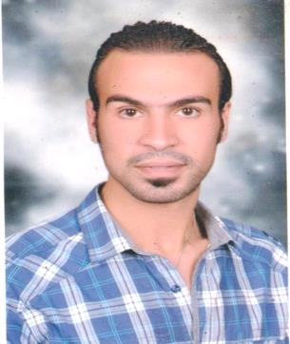  
PERSONAL DATA**

Name: Mohamed moustafa Mohamed

Address: 52 sife st, Sidi Bishr, Alexandria, Egypt

Date of Birth: 25/07/1987

Nationality: Egyptian

Marital Status: Married

Military Status: Examped

Mobile: +2 01227199842 \ 01002220553

E-mail : samoselim193@gmail.com

**EDUCATION**

* Donbosco Institute Diploma

Year: 2005

Donbosco Italian Institute, Alexandria, Egypt

Specialization Mechanics

**CAREER HISTORY**

**- Work in the field of tourism in Aswan and sharm Governorate for two years**

- Work in garment manufacturers for three years

- Work at Lecico Ceramics for five years (current work)

I was working on the CNC machine to manufacture ceramics with its masters and its height.

- Worked at toxido for classic suit for three years

Branch manager

- Worked at tai house for classic suit for two years

- I worked in the field of limousines to airports and travel in general for 3 years

**LANGUAGE SKILLS**

* Arabic: mother tongue
* Italian: fluent
* English: good

**COMPUTER SKILLS**

* Fidelio hotel system
* Nabilio hotel system
* Comsys hotel system
* Auto Cad
* Microsoft Office Word, Excel, Power Point
* Internet