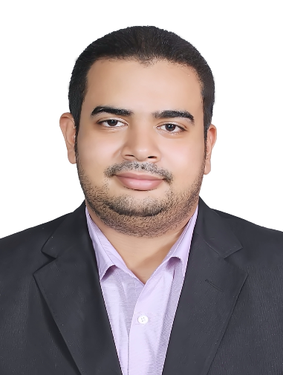

**Mohamed Gamal Abdelaleem**

I am currently looking for a full time position in an environment that offers a greater challenge, increased benefits for my family, and the opportunity to help the company advance efficiently and productively



Bachelor of Commerce Benha University.

Section : Accounting

Graduated 2012

- Highly and eager to learn new things.

- Strong motivational and leadership skills.

- Ability to produce best result in pressure situation.

- Excellent communication skills in written and

verbal both.

- Ability to work as individual as well as in group.

PERSONAL SKILLS

**- Financial accountant at Mistafa Fayad Office From 2013 To 2018 .**

**- Assistant manager at Total Stations From 2018 To 2019.**

**- Banker At Reefy Company From 1 Jan 2019 To 2 Julie 2019.**

**- Accountant At Devorag Company Real State Marketing From 7 Aug 2019 To 7 Oct 2019.**

**- Real State Marketer In Sama Company From 15 Oct To 15 Jan 2020.**

EXPERIENCE

English

Arabic

LANGUAGES

**Date of birth** : 21/8/1990

**Nationality** : Egyption

**Marital status** : Single

**+2001285634873**

**mohaamed.raagab@gmail.com**

**Cairo - Egypt**

CONTACT

EDUCATION