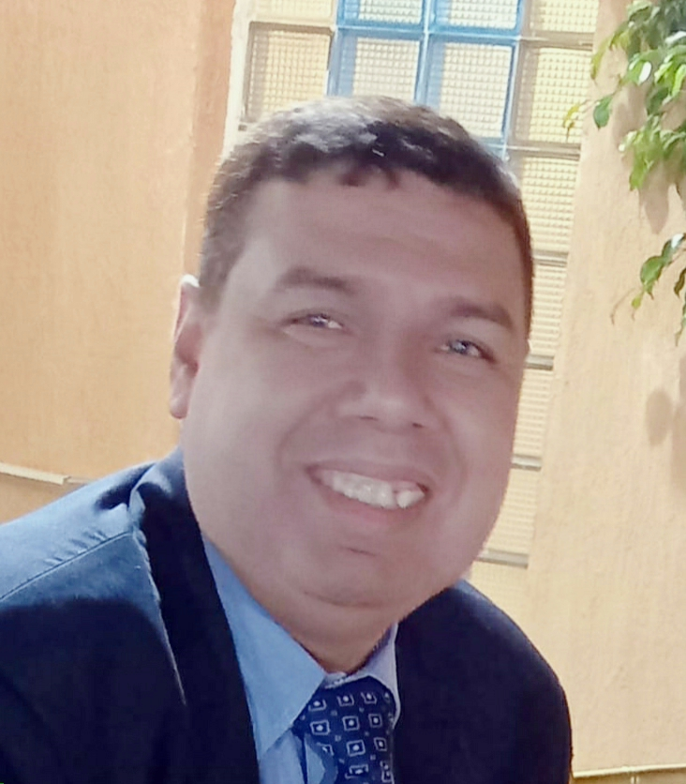

Ashref Abdel Hamid Kamel
22nd.Ahmed Abdel-Aziz .Faisal –Giza
01017774343 - 01115976206 - 01019843627
doniaasraf@yahoo.com

Personal Data:
Nationality : Egyptian.
Date of birth : 11th. Aug. 1969
City of birth : Cairo
Religion : Muslim.
Marital Status : married
Military Status : Completed

Education & Qualification:
University : Cairo Univirsity.
Graduation : Commerce.
Degree Acquired : B.Sc. General.
Grade : Pass
I have a Diploma in Accounting and Auditing good degree
( Cairo University.)
I holds a diploma degree in taxation good ( Cairo University.)
Holds a charered accountant degree from the ministry of finance

Training:
Computer systems for accounts Diploma
V.B6 courses
Microsoft office programs (Excel, Word, access,etc

Experience Job :

Kuwait Investment Company
Office Tariq Saeed accountant and auditor
Senior financial Accounting ( ISLOAN EGYPT )
Chief accountant ( ISLOAN EGYPT )
Chief financial Accounting ( Medicare )D.r/Hosaam badray
Account Manager ( Digital vision )
Financial Manager ( EMDAD )
Financial Manager queen school international
Account Manager Nile Badrawi
Financial Manager wayana foundation
Financial Manager Swiss Contracting
Financial Manager dezino
Financial Manager world kitchen

profile:

Seeking for a challenging position in Accounting to build upon my Skills & creative abilities.

Employment history Experience:
- Book keeping(sales , purchasing , cash day book , creditors ,Taxes , administrative expenses , general expenses , selling and distribution expenses , general ledger , inventory book , banks , debtors )
- making a journal entries
- trial balance
- final accounts
- profit & loss A/c
- financial position

Achievements:
Able to made monthly income statement.
Able to work as ( chief accountant).
Prepare reports of production costs

Skills:
. Hard Worker
. Ability to work in pressure
. Good Communications Skills
. High Team-Work spirit
. Fair English language.

