Hassan Ahmed Hamed Ahmed
مكان الصورة
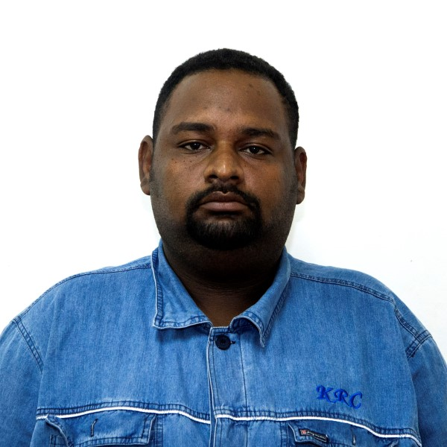

Khartoum refinery Co. ltd

Khartoum North, Al Gaily, Khartoum, Sudan

Telephone (direct): (+249)185 350000 – 8109
Mobile +249 9 12103554 - +249 9 12313491

E-mail zunger28@gmail.com
PERSONAL INFORMATION:
Date of Birth | May .04. 1986
Gender | Male
Marital Status | Married
Nationality | Sudanese
Military Service | completed

EDUCATION:
American east coast university  (BSc in civil engineering ) | May 2013
Sudan University for science & Technology –college of technology department of civil and environmental engineering  Diploma in Environmental Engineering | December 2005
EXPERIENCE:
Khartoum refinery Co. ltd  Production and operation Department /CCR&GDHT unit FIELD & PANEL  - Able to operate, monitor and control my assigned work area through DCS with PLC based ESD and Fire and Gas monitoring and protection systems safely & efficiently, to achieve target plant yield without any hydrocarbon loss and with in emission limits, and ensure effective hand-over on shift changes and provides process data to area shift personnel. Able to give DCS simulator training.  - Fully conversant with safe & efficient operation control and maintaining the Optimum process parameters of CCR&GDHT Plant.  - Posses good knowledge in the operation of Distributed Control .  - Extensive operational characterization and data interpretation skills.  - Familiar with regulations of company’s work permit systems for Hot & Cold works. | October2008-present
Details of experiences :

- Stripper Column Operations
- Satbilizer column operation
- Fixed bed catalytic reactor operation
- Contenous catalytic reforming unit operation
- Multi Stage Compressors Driven By steam turbine
- Receprocting compressor Driving by electrical motors

TRAINING:
Projects management | petroleum training center
Skill to deal with managers | petroleum training center
Supervision skills | petroleum training center
Computer skills | Khartoum refinery company ltd.
General safety Awareness | Khartoum refinery company ltd.
SKILLS:
Language | good in Arabic and English
Computer knowledge | Windows, Ms Office, AUTO CAD

REFERENCES:

1- Tarig A. rahman - Khartoum refinery Co mobile cell :00249912141207

2- osman hussain 00249912131234

