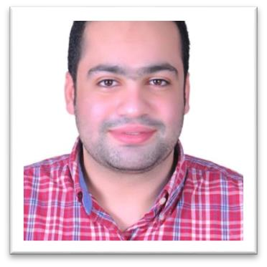

Name: Essam ahmed mohamed essam Eldine radwan.

Age: 33.

Born: 28/8/1991.

Graduated from language school.

Have a license in English arts with satisfactory grade graduation year 2012.

1 year as a secretary in translation bureau

2 years as an operator and receptionist in grand Rotana at sharm El sheikh.

2 year and a half as a telesales and admin in an export company {desert farms} of herbs and spices.

Lives in Dokki , Giza , Egypt.

Certification of ICDL.

2 months as a public relations trainee at Egypt airport from Egypt air.

English conversation certificate from League of Arab States.

English skills: very good.

My statement from army: exempted

Mobile number: 01032762711 / 01118417864

My email: essamradwan204@gmail.com