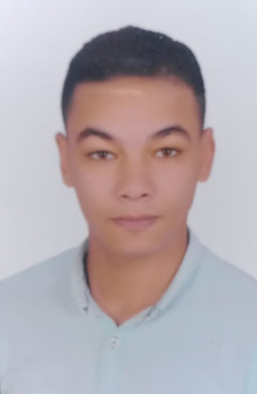
Abdallah Araby Selem Mohamed
Faculty of Arts - Alexandria University
Address: Bakous, Alexandria, (Egypt)
Mobile: (+20)1001206351
Email: abdallaharaby23@gmail.com
Birth date: August 31, 1998
Marital Status: Single
military service completed
Education:
- Graduated from Alexandria University, Faculty of Arts,
Department of Geography and GIS, May 2021
Working Experience:
- El tazeg waiter 2016-2017
- Hardee's waiter 2017-2018
- Papa John's waiter 2018-2019
- Burger factory supervisor 2019-2020
- Butcher for 3 years family business
- A contractor in the field of instructions and building for 8years family business
Interests:
- Social media - teaching - reading books and novels - self-development
- Attending work related and personal development conferences & workshop.
Skills and Abilities:
Communication:
- Persuasive and a good client communicator.
- Excellent rapport building and presentation skills.
- Provides exceptional customer service to staff and the public.
Coaching and training:
- Learned new skills and developed expertise within the training and development scope of practice.
- Swimming coach
- English trainer
- Provide ongoing mentorship and coaching to staff.
Computer skills:
- MS Word - MS Excel
Other soft skills:
(Time management - Self-management - Planning - Negotiation - Motivation)
Language:
- Arabic: Mother tongue
- English: B2
- Italian : A1

