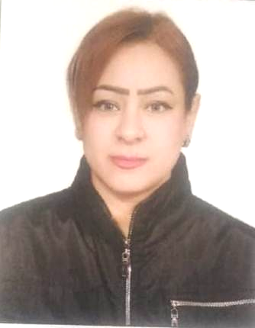
Hanaa Fayez ragheb

Mobile:: 01029747765 - 01283992113
Email: jasmienlove44@gmail.com
Date of Birth: 16/1/1987.

Personal Statement
I Am Willing To Find A Better Job That I Can Learn From. I Am An Active Person
Who Likes To Hold onto Responsibilities or Manage Any Other Position That Suits My
Experiences. I Am Seeking a Promising and Challenging Opportunity That Can Enhance
My Knowledge and Experience.

Education
Diploma in Commerce, Al-Awqaf Secondary School for Girls

Work History
I worked as an engineering office manager for a year and a half
Executive secretariat for a law firm
I worked as a Quality Supervisor at Eva Cosmetics for two years 2015
I worked as a cleaning supervisor at the Regency Hotel for 6 months
I worked as a cleaning supervisor at Hotel Royal for a year
I worked as a cleaning supervisor at the Saudi embassy for 5
Skills
Advanced File Management Organizational Skills
Advanced Internet & Email Skills Researching Skills
Computer Skills Touch-Typing Skills (Ergonomic Keyboard)
Telephone Answering Skills Interpersonal Communication Skills

PERSONAL SKILLS

o Co-Operative, Self-Motivated, Dynamic And Able To Work Under Strenuous Circumstances.
o Ambitious And Willing To Learn Quickly.
o Ability to Handle Many Tasks under Pressure.
o Good Written and Verbal Communications.
o Ability to Work among Team Group.
o Very Hard Worker

Computer Experience

o intermediate Capabilities Of Windows XP.
o intermediateUser MS Office XP,7, Word, Excel
o intermediate English & Arabic Email Capabilities & Internet Applications.

Languages

o Arabic (Mother Tongue).
o Good in (Written& Reading) English Fair in Speaking.

Hobbies & Other Interests.

o theatrical Director
o Reading.
o Listening To Music.
o And Surfing the Internet.

Personal Information

o Name: Hanaa Fayez ragheb
o Nationality: Egyptian.
o Place of Birth: Cairo.
o Date Of Birth: 16 jan 1987 .
o Address: 10 elnasr st . from elbasrawy st. elmounira elgharbia .– embaba – giza
o E-Mail: : jasmienlove44@gmail.com
o Mobile: 01029747765 - 01283992113

HOPE MY QUALIFICATIONS MEET YOUR DEMANDS

