AHMED HASSAN ATWIYA

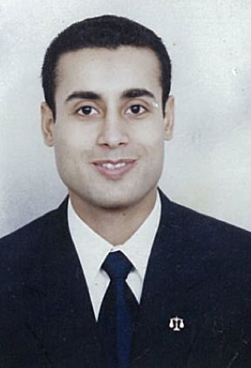

EL KHAMAEL CITY, EL SHIKH ZAYED

6 October, EGYPT.

Phone: 01007598237

Email:

[Atwiya77@gmail.com](mailto:Atwiya77@gmail.com)

OBJECTIVE

* Willing to join a big organization where my aims could be achieved and utilized my qualifications, skills, experience and education.
* Seeking a challenging position for gaining more experience, getting new concepts, obtaining opportunities for learning and developing.
* Hopping to join HR team to achieve my aims, develop my learning and skills.

EDUCATION

* Faculty Of law.

Cairo University (2002).

Personal Data

* Date of Birth: 19 Jun. 1977
* Place of Birth: EL AGOUZA, EGYPT.
* Gender: Male.
* Nationality: Egyptian.
* Religion: Muslim.
* Marital Status: Married.
* Military Status: Exempted.
* Residential: Available anywhere.
* Contact Info: (Address): EL Khamael City, EL Sheikh Zayed 6 October, Egypt.

(Mobile): 01007598237

(Email) : atwiya77@gmail.com

|  |  |
| --- | --- |
| Currrnt work | |
|  | Human Resources at SIGMA TEC PHARMACEUTICAL INDUSTRIES Co. From 1.7.2006 Until Now as a personal unit head responsible for recruitment . | |  |

EXPERIENCE

(1)Lawyer at Lawyer's office.

(2)Management Resources. (Airport)

(3)Data Entry. (International Professional for Trading Services).

(4)A lawyer at the Modern Paints Company.

ADMINISTRATION

Develop and execute SIGMATEC policies, procedures, systems, resources, and communications to maximize efficiency, reduce costs, increase quality and promote innovation and excellence in administrative related matters.

Qualifications & Skills

* Good communication skills.
* Creative thinking, team work orientation, hard working, self confidence.
* Reliable, strong attention to details.
* Ability to work independently and as part of team.
* Interactive and very fast to learn new technologies and science.
* Ready to Work Under Pressure.
* Quick Adaptation to Various Work Environments.
* Able to maintain professional demeanor and appearance.

Language Skills

* (Arabic): Excellent (The Mother Tongue).
* (English): very good command of both written and spoken English.

OComputer Skills

* Excellent in all computer hardware and software.
* Excellent in Microsoft Office (XP – 2003 – 2007).
* Excellent in Internet.

COURSES

* English course including General & conversation from language institute for armed forces.
* Microsoft Office (Word – Excel), 3D Studio Max.
* H.r training course.(Cam)
* H.r Diploma (Cambridge College).
* Ready to join any course on my own to develop and provide myself in my field (work) no matter what it will cost.

Hobbies

* Reading, Swimming & Riding horses.

Future Goals

* Develop my skills and experience in all fields.
* Learning more foreign languages and soft skills.
* Join more courses and studying to develop and provide myself.

REFERENCES AVAILABLE UPON REQUES …