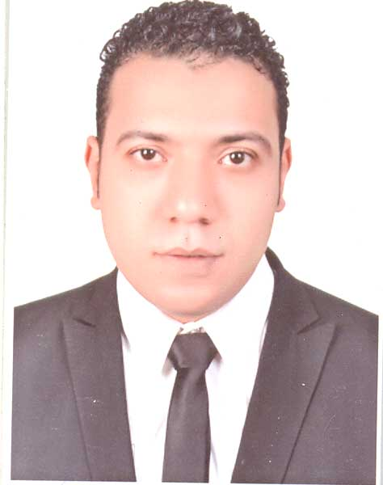
Shrief Mohamed Moatasem Ali
13 elnasr st. Takseem elpetrol. Assiut
Mob: +2 01014131151
Email: mr_shrief88@yahoo.com
Date of birth: 1 november 1988

Objective

A self-motivated and a hard working seeking to share and gain experiences in a dynamic atmosphere, preferably a multinational company.

Current Experience
From may 2023 to yet :

I start working Sales outdoor in etisalat_eg (corporate)

From October 2022 to April 2023 :

Started working in kamal othman company group for Oils&Greases

From October 2017 _ to June 2022 :

I started working in a private job and remind an agent for Apsco oil company in Assiut.

March 2016 _ to July 2017 :

Sales supervisor in the same company in (Qena. Luxor and Aswan)

December 2012 – to date:Area Sales Representive in petromin company for Oils&Greases (Assiut East, Assiut West, Mnaqbad,and Aziyah )

      - Following up existing accounts, obtains new orders and establishes new accounts by planning and organizing daily work schedule to call on existing or potential sales outlets and other trade factors.
      - Focuses sales efforts by studying existing and potential volume of dealers.
      - Submits orders by referring to price lists and product literature.
      - Keeps management informed by submitting activity and results reports, such as daily call reports, weekly work plans, and monthly and annual territory analyses.
      - Monitors competition by gathering current marketplace information on pricing, products, new products, etc.
      - Recommends changes in products, service, and policy by evaluating results and competitive developments.
      - Resolves customer complaints by investigating problems; developing solutions; preparing reports; making recommendations to management.
      - Provides historical records by maintaining records on area and customer sales.

Past Experience

May 2011 till November 2012: Sales Representive in Elyadak company Group. (Sohag,Tema,Tahta,Elmaragha,Gerga and El Baliana)

      - A comprehensive survey of the area and collect a large database.
      - Arranges appointements with big costumers and retail.

September 2010 – April 2011: Researcher (opinion polls) in Central Agency for Public Mobilization and Statistics and Center for Political Studies and Stratigic Al-Ahram newspaper (Assiut,Sohag and New Valley)

- Do opinion polls with citizens to discuss some of the issues of social, political and economic.

Education

Bachelor of Law University of Assiout.
Date of Graduation: June 2010

Skills
Good listener,Presentation Skill, Target oriented, Negotiation skills, Self-Confidence, Product Knowledge, Addressing Customer Needs, Motivation for Sales, Sales Planning,Building Relationships, Client Relationships, Market Knowledge, Motivating Others.
Computer Skills

Efficient in:
- Windows (2000, 2003, XP, 2007)
- Microsoft Office
Word, Excel, PowerPoint, Internet fundamentals

Training Courses

- Advanced Selling Skills
- Negotiation Skills
- Creative Thinking
- Presentation Skills

Languages:

  - Arabic (Mother Tongue)
  - English (Good)

Hobbies and Activities

Football, Basketball, Traveling,Billiards and Swimming.

I hereby certify that all the aforesaid statements are true and correct to the best of my ability, and that any further information or documents shall be presented upon request

