**CURRICULUM VITAE**

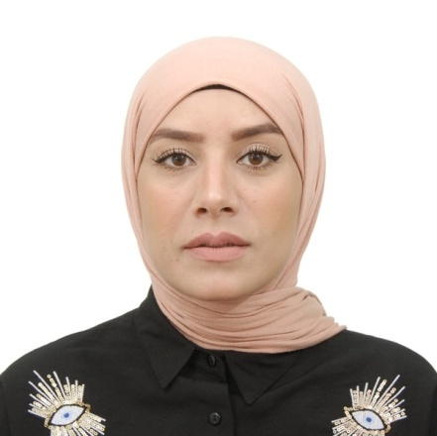

**Civil status:**

* Name: HADDOU
* First name: YAGOUBIA MARWA
* Date and place of birth: 05- 07 - 1992 at SIDI BEL ABBES
* Social situation: Single
* Nationality: Algerian
* Address: SIDI ALI BOUSIDI SIDI BEL ABBES
* Mobile No +0213 659211888 / 659605991
* Email: [marwasba05@gmail.com](mailto:marwasba05@gmail.com) / marwa.haddou@univ-sba.dz

**Diploma Obtained:**

* 2010: Baccalaureate in science.
* 2013: Bachelor’s degree in Mechanical Engineering specialty Aeronautical Structure.
* 2014: training in/ SWISS ELEARNING INSTITUDE/ Presentation And Communication Skills.
* 2015: Master in Mechanical Engineering
* 2019-2020: 5th Year Doctorate in Mechanical Engineering (Mechanics of Materials)
* 2023: English for Business and Entrepreneurship Self-Paced MOOC 2023 by The Online Professional English Network is a program sponsored by the U.S. Department of State with funding provided by the U.S
* 2023: certificate of English for level B1-2 by university of Sidi Bel abbes faculty of letters, languages

**Work experience:**

* PhD student at the Mechanical Engineering Laboratory (LMPM, Sidi Bel Abbes, Algeria)
* Short-term internship at the mechanical laboratory of Sousse (LMS)
* Volunteer as lead photographer at the faculty of technology of Sidi Bel Abbes Algeria for participation of the interstellar club in the session (question / answer) of the competition 2021 Virtual Spaceport America's Cup June 18-20/2021.
* Volunteer as lead photographer at the faculty of technology of Sidi Bel Abbes Algeria for open door to aeronautics.
* Measures the Logicels well (Lightroom, Photoshop, Abaqus, all Microsoft office programs (Word, Excel, Powerpoint), etc.)

- Attestation of Participation/International Exhibition of Autonomous Aerial Vehicles, Aeromodelling and Simulation .(2014 )

- Certificate of Participation for a training of creation of institutions organized by the national agency for youth employment and the entrepreneurship house.

* More than 5 years experience in E-commerce with international company.
* Photographer, Designer
* Excellent salesperson (field experience)

**Field of research:**

* Aircraft structure.
* Aviation materials.
* Study of the influence of the nature of the preparation of the surfaces of the substrates and the influence of addition charge on the mechanical behavior of the adhesive in an assembly

**Language Proficiency:**

* Arabic: well written, well spoken.
* French: well written, well spoken.
* English: well written, well spoken.

**Social skills and competencies:**

* Sense of responsibility and relationship.
* Listening and initiative
* Active and motivated.

**Educational Activities:**

* Education
* My first teaching experience took place during the preparation of my doctorate. I ensured the teaching of the practical work included in the thematic material for the engineer.
* Currently, I teach at the Faculty of Technology (Sidi Bel Abbes).
* The nature of each lesson is detailed below:
* practical work: (Fluid mechanics - computer science - technical drawing )
* Co-supervision of masters.
* International conference participation :
* The ninth international Congress desigh and modelling of mechanical systems December 20-22-2021 (CMSM 2021) Hammamet Tunisia
* The 2nd International Conference on Materials Science and Engineering and their Impact on the Environment (ICMSE@2021) Sidi Bel-Abbès 03 and 04 July 2022