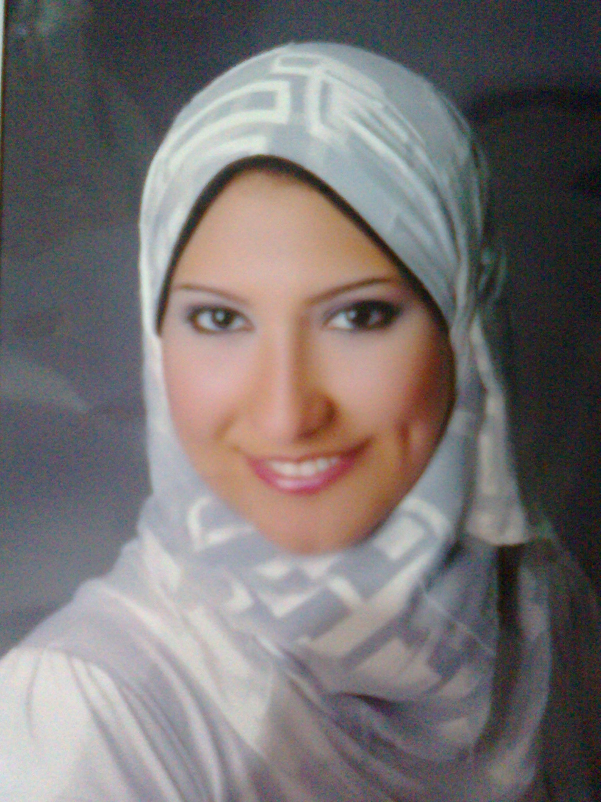
Curriculum Vitae

Ayat Hosny Abd El-Ghany Ibrahim

Personal Details :

Name : Ayat Hosny Abd El-Ghany Ibrahim.

Date of Birth : 27/8/1988.

Place of Birth : Alexandria – Egypt.

Religion : Moslem.

Nationality : Egyptian.

Marital Status : sengil.

Home Address : 25 St. from 16 St. El-Falaky Alexandria.

Home Phone No : +2 03 5358105

Mobile No. : 012 89171512.

E-Mail : auotamm2004@yahoo.com.

Position : social worker.
EDUCATION

- Bachelor social work Alexandria University  2010.
- High School Degree 2005.
- General education diploma 2012.

Career Related Experience

- Training in Language center.
- Working in wear shop.
- Training in assembly society development.
- Working in insurance company.

Computer and Language Skills

- Good in both spoken and written English and Arabic.
- ICDL course in top academy.
- Two levels conversation.

Interpersonal Skills

- Working under pressure.
- Fast learner.
- Ability to identify & solve problems.
- Good communications with people.

