CURRICULUM
VITAE
GENERAL INFORMATION  NAME: Nancy Mohamed Hassan Negm  Affiliate: Suez Canal University- Faculty of Tourism and Hotel Management  Company address: Ismaïlia , Egypt.  Phone number: +201101320831  Fax number:  E-mail: Nancyngm488@gmail.com  Nationality: Egyptian  Date of birth: 15/8/1976  Gender: Female | 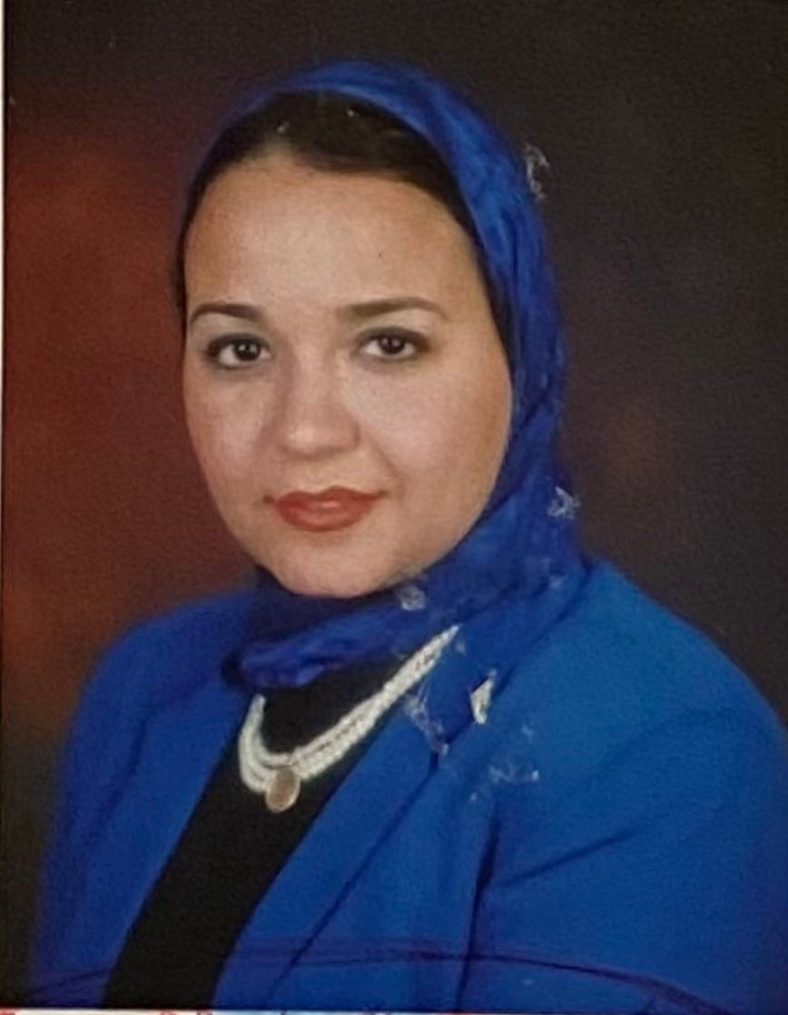

STATEMENT OF EXPERIENCE

Description of professional qualification: Bachelor of Alsun- German Department
Description of main professional experience:
1-German Lecturer Suez Canal University –Faculty of Tourism and Hotel Management (23 Yrs working experience)
2- German Lecturer Suez Canal University –Faculty of Agriculture (23 Yrs working experience)
3-German Lecturer Higher institute for Tourism and Hotels (Egoth ) Ismailia (16 Yrs working experience)

PROFESSIONAL EXPERIENCE

Dates: Jan 1999 to Date
Name and address of employer: 1-German Lecturer Suez Canal University –Faculty of Tourism and Hotel Management
Type of business or sector: German Language Lecturer
Occupation or position held: German Language Lecturer

Main activities and responsibilities:
Manage all Teaching activities on the Campus .
- Introduced new teaching, tools and techniques to the University
- Initiated and achieved improvements in performance in meeting legislation and regulatory requirements regarding teaching German Language in University of Suez Canal
- Implemented standards, appropriate specifications and guidelines for system and Methodology of teaching the German Language syllabus in Egyptian Ministry of Higher Education .

- Developed staff of post graduate students through Coaching,, training and mentoring.
- Schedule management for German Language examinations .
- Preparing exams for Grade 1-2-3-4 of Faculty of Tourism and hotel management
- Preparing exams for Post Graduate studies of Faculty of Tourism and hotel management/Faculty of Agriculture
- Preparing exam results reports for head office.
- Preparing QMS monitoring and measuring reports for teaching German Language

Dates: Jan 1999 to Date
Name and address of employer: 1-German Lecturer Suez Canal University –Faculty of Faculty of Agriculture
Type of business or sector: German Language Lecturer
Occupation or position held: German Language Lecturer

Main activities and responsibilities:
Manage all Teaching activities on the Campus .
- Introduced new teaching, tools and techniques to the University
- Initiated and achieved improvements in performance in meeting legislation and regulatory requirements regarding teaching German Language in University of Suez Canal
- Implemented standards, appropriate specifications and guidelines for system and Methodology of teaching the German Language syllabus in Egyptian Ministry of Higher Education .
- .
- Developed staff of post graduate students through Coaching,, training and mentoring.
- Schedule management for German Language examinations .
- Preparing exams for Grade 1-2-3-4 of Faculty of Tourism and hotel management
- Preparing exams for Post Graduate studies of Faculty of Tourism and hotel management/Faculty of Agriculture
- Preparing exam results reports for head office.
- Preparing QMS monitoring and measuring reports for teaching German Language

Dates: Jan 2006 to Date
Name and address of employer: German Lecturer Higher institute for Tourism and Hotels (Egoth )
Type of business or sector: German Language Lecturer
Occupation or position held: German Language Lecturer

Main activities and responsibilities:
Manage all Teaching activities on the Campus .
- Introduced new teaching, tools and techniques to the German Lecturer Higher institute for Tourism and Hotels (Egoth
- Initiated and achieved improvements in performance in meeting legislation and regulatory requirements regarding teaching German Language in University of Suez Canal
- Implemented standards, appropriate specifications and guidelines for system and Methodology of teaching the German Language syllabus in Egyptian Ministry of Higher Education .

- Developed staff of post graduate students through Coaching,, training and mentoring.
- Schedule management for German Language examinations .
- Preparing exams for Grade 1-2-3-4 of German LanguageHigher institute for Tourism and Hotels (Egoth )
- Preparing exam results reports for head office.
- Preparing QMS monitoring and measuring reports for teaching German Language

- .

EDUCATION

Dates: 1995 to August 1999
Title awarded: Bachelor of Alsun-German Department
Name of the courses: Bachelor of Alsun-German Department
Name of school/university providing education Ain Shams University, Egypt

TRAINING & QUALIFICATION

Dates: 2006-2008
Title of qualification awarded: Diploma of Hotel Management
Principal subjects covered: Diploma of Hotel Management ( 2 Yrs)
Name and type of organization providing training: Helwan University –Faculty of Tourism & hotel Management& Nutrition Management , Egypt

Dates: 2005
Title of qualification awarded: Diploma of German Language
Principal subjects covered: Diploma of German Language
Name and type of organization providing training: Faculty of Alsun Minia University

Dates: 2016
Title of qualification awarded: Master Degree in Hotel Management
Principal subjects covered: Master Degree in Hotel Management
Name and type of organization providing training:. Helwan University –Faculty of Tourism & hotel Management& Nutrition Management , Egypt

Dates: 2017-2018
Title of qualification awarded: Pre-PHD Studies in Hotel Management
Principal subjects covered: Pre-PHD Studies in Hotel Management
Name and type of organization providing training: Helwan University –Faculty of Tourism & hotel Management& Nutrition Management , Egypt

LANGUAGES

Mother tongue(s): Urdu
Other language(s) Listening Reading Spoken interaction Spoken production Writing
German
English
Arabic A A A A A
A: Excellent, B: Very good, C: Good, D: Basic knowledge

SPECIAL FOCUS ON INDUSTRY PROJECTS
MOST RELEVANT RECENT PROJECT

COMPUTER SKILLS AND COMPETENCES

Software knowledge: Windows, Microsoft Word, power point and Internet

MEMBERSHIPS

OTHER SKILLS AND COMPETENCES

