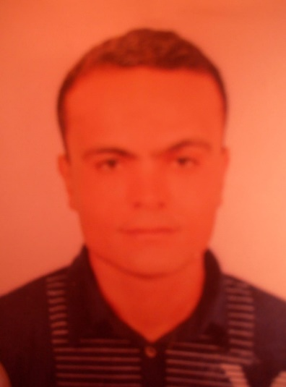**Farid shawky Abou-Elfetouh Elmeligy**

**Nationality:** Egyptian

**Mobile Phone:** + (20) 01004349332

**Personal Information**

**Nationality:** Egyptian

**Gender: Male**

**Birth of Date: 25/3/1982**

**Marital Status: married**

**Place of date: El-Menoufia government, Egypt**

**Military status: Exempted**

**Education**

**Holder of a Bachelor's degree in Science and Education, 2003.**

**Languages**

* **Arabic Native Language**
* **English Very Good**
* **Italy Very Good**

**Computer Skills**

**Operating Systems**

- **Windows XP/2000/vista/7/8/8.1** ExcellentCompetent

**Productivity Suites**

- **Microsoft Office 2010, 2003, 2007, XP** Very Good Competent

( ICDL Course from El-Unisco)

**Experiences**

* **Experience in the tourism sector**
* **As a sales representative,**
* **In the paint industry,**
* **In human resources,**
* **And in agricultural work.**