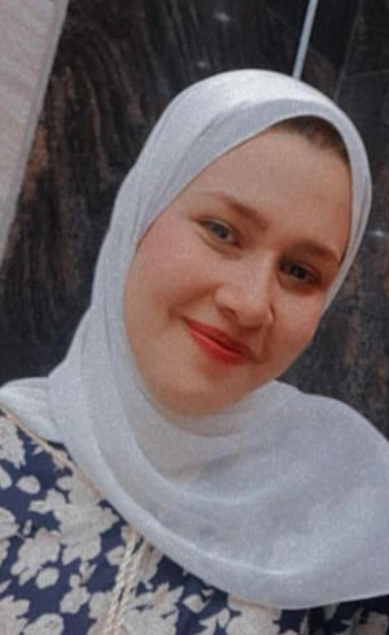 **Personal Information**



**Aya Sayed Ibrahim Mohamed**

**01013910106**

**0223765757**

**El-Maasra** **- Helwan- Cairo- Egypt**

**ayasayedut@gmail.com**

|  |  |
| --- | --- |
| **Personal Details :** |  |
|  | |

· Date of birth · **01/04/1997**

· Place of Birth · **Cairo, Egypt**

· Religion · **Muslim**

· Nationality · **Egyptian**

· Marital Status · **Single**

|  |  |  |  |  |  |
| --- | --- | --- | --- | --- | --- |
|  | |  |  | | --- | --- | | **Educational Qualification:** |  | |  | | |

· **Bachelor from Faculty of Tourism and Hotels Management – Helwan University** .

· **From** **2017** **- 2021**.

· **Degree** **Is** **Above Average.**

|  |
| --- |
|  |

|  |  |  |  |  |  |
| --- | --- | --- | --- | --- | --- |
|  | |  |  | | --- | --- | | **PERSONAL Skills& Activity:** |  | |  | | |

* Ability to learn, acquire and work under stress.
* Ability to contribute in a team work.
* Easily acquainted with new challenges and work hard to achieve them. • Strong understanding of the Middle East Market and culture
* Throw own experience and internet self-study.
* Excellent communication and negotiation skills.
* Very patient in dealing with different situations and the team work.
* **Experiences:**
* **Working as a receptionist**

**at a translation center.**

* **Working as a secretary at lawyer’s office.**

|  |  |  |  |  |  |
| --- | --- | --- | --- | --- | --- |
|  | |  |  | | --- | --- | | **Computer skills** |  | |  | | |

* **Microsoft** **office** **Word,Excel.**
* **Good** **at** **Performing** **General** **Computer** **Tasks.**

|  |  |
| --- | --- |
| **Language skills** |  |
|  | |

* Native language: (Arabic).



* foreign language: (English).

* **Fluent** **in** **Arabic** **and** **Good** **at** **English**.