**PERSONAL INFORMATION:**

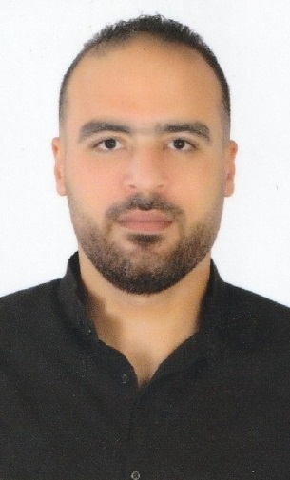

**Name: Mohamed Adel mohamed mohamed yossef elwshahi**

**Religion Muslim**

**Egyptian nationality**

**Date of Birth: 5/3/1989**

**Phone number&whatsapp:00201206765916**

**Military service position: final exemption**

**Passport number: A28471851**

**Address: Alexandria _Egypt**

**Email:** [**mohamedelwshahi329@gmail.com**](mailto:mohamedelwshahi329@gmail.com)

**QUALIFICATIONS**

**-College of Technology, Bachelor's degree, Business institutes, Accounting for financial institutions (Graduation year: 2008)**

**-10 Lectures for Excellence in the service of the filling in Academy of Business and Human Resources.**

**EXPERIENCES**

**•Customer Service Officer at Royalty for Paints and Chemicals 2/2008 until 9/2009**

**•Accountant in ships and boats oil services company from 10/2009 to 12/2010**

**•costumer services for Riyadh Alexandria General Contracting Company in Saudi Arabia from 2/2011 to 7/2012**

**• General Manager in Sanara Seafood Restaurant Saudi Arabia from 10/2012 to 2/2014**

**• Accountant in Rehab Tabuk Hotel Suites in Saudi Arabia from 1/2015 to 3/2016**

**• GeneralManager of Rehab Tabuk Hotel Suites in Saudi Arabia from 3/2016 to 1/2021**

**•Data Entry in Radisson Blue Hotel _ Dubai _ UAE from 9/2021 to 8/2022**

**SKILLS**

**• The ability to make decisions • The ability to manage time**

**• Computer Literate • Planning and Follow-up**

**LANGUAGES**

**•Arabic ( mother tongue ) • English (good)**