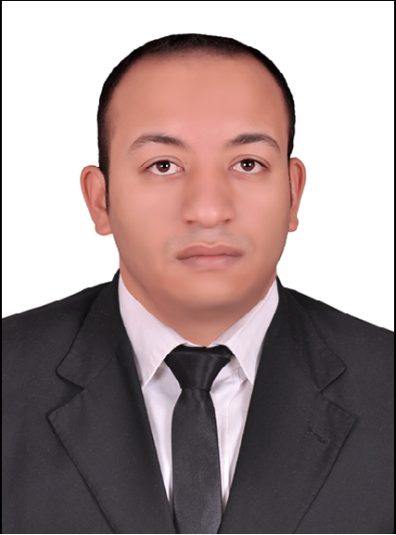
Ahmed Abd-rabu Awad Abd-rabu.
Elqanater alkhayria, qalubia, Egypt.
Mobile 1 :( +2) 0106-2211136
Mobile2 :( +2) 0112-7799292
Email: Ahmed.abdrabu1988@gmail.com

Key Qualifications & Achievements:

- Graduated from faculty of commerce, accounting major, in the year of 2012.
- Accounting course at Arab bureau group for accounting consultation.
- Experienced with more careers for 5years (with summer work).

Work experience: (current) .

- Start date: mars 2nd 2013 till: now .
- Company name: Elnour for electric cables.(rotana cables).
- Business field: making and trading electric cables.
- Job title: sales and financial manager.
- Job description: responsible for handling accounts receivables and accounts payables .
- Responsible for received invoices from customer and revise it then added it in them accounts.
- Responsible for revising vendors invoices and them accounts.
- Responsible for betty cash and payroll to transferred it to employees .
- Make control on store and revise its accounts.
- Meeting customers and vendors to revise accounts then prepared sheet to management.

Work Experience: till mars 2013.

Start Date: June26, 2012 till: 1st mars 2013.
Company Name: Rooya markets for trading and distribution .
Business Field: Trading mobiles and Electronic devices.
Job Title: Accountant and sales man.
Job description: Responsible for handling sales and the relationship with customers and suppliers, then preparing accounts sales , customers and suppliers ,and in the end of day preparing accounts resulting of trading today and submit the financial report to the director.

Work Experience: (summer work)

Start Date: Feb. 16, 2011 till: May 19, 2012 (Year & 3 Months)
Company Name: ECITA (Entertainment and security services company ).
PLACE OF WOrK: MIVAN LIMITED EGYPT (multinational company).

Business Field: constructions (Cairo festival city project).
Job Title: Receptionist and security supervisor .
Job description: Responsible for organizing meeting and handling visitors and leading security staff at company’s sites.
Relationship with accountant career: help financial department by receipt invoices from suppliers and sub contractors after revising it and delivered chiques to them.

Summer work: (free works)

- (july-2006tillOctober-2006)_(july-2007till-October-2007)_(august
-2008till-October-2008).
- (july-2009till-November-2009)_(july-2010till November-2010). Work as sales man at elghezzawy mall for trading.
- Business field: mobiles and electronic devices

Educational Qualification:

_ Bachelor of Commerce, Faculty of Commerce, Cairo University.
Graduation Date : May 2012.
Major : Accounting. (62.5%).
Percentage of final year: (72%).
Percentage of accounting subjects for four years: (78%).
_ Accounting course at Arab bureau group for accounting consultation.

Courses attended & Certificates:

      - English courses at Cairo university and self study.
      - Microsoft Applications (windows, word, excel and internet).
      - Computerized accounting courses (sage software ;peach tree – quick books – financial excel) at cairo university.

Languages:

Arabic : Mother tongue.
English : good. (Writing, Reading and Speaking)

Personal Data:

Name :Ahmed Abd-rabu Awad Abd-rabu Husain.
Nationality : Egyptian.
Date of birth : July 1st 1988.
Military service : postponement.
Marital status : single.

Another skills: .

- Ability to work under stress.
- Ability to work with all levels of management.
- Ability to learn new tasks easily.
- Very good communication skills.

