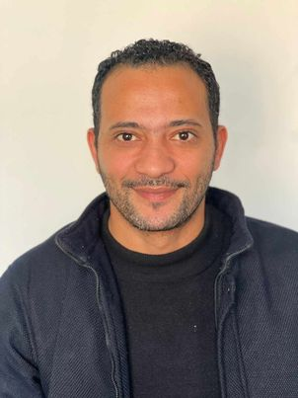

Mohamed Aly El-Abd   
Address: 4 Gasr El-Suiz St., Heliopolis, Cairo

Telephone: 01016162356

Email: [memobeh@live.com](mailto:memobeh@live.com)

**EDUCATION:**

New Cairo Academy

information system 2014

**WORK EXPERIENCE:**

**\*IT Administrator**

Sekem - Cairo

June 2023 till Now

Support more than 200 users.

working and managing environment contain:

* G suite and Google Drive
  + Administer and configure all of Microsoft windows 7, 8 ,10 and 11.
  + Administer and configure Linux operating systems.
  + LAN / WAN / Wireless and TCP/IP Protocol.
  + Perform data backups and disaster recovery operations.
  + Managing & Applying security and policies for all domain clients.
  + Installation and administration of antivirus management server software.
  + Troubleshoot networks, systems, and applications to identify and correct malfunctions and other operational difficulties.
  + Maintain hardware and software for user’s Pc’s.
* Installing and maintaining various standard software as per user requirements.
  + Solving Problems and errors.
  + Continue daily for all devices in the company.
* Everything integrated with the help desk.

**\*Supervisor at FSC (Flying Studies Center)** 2017 till nowSupervising for Practical and Theoretical Training Center for cabin crew at EAA (Egyptian Aviation Academy) cooperating with FSC.  
  
Responsible for Paperwork, Registrations, and Interviews

**Other working experience:**

* Downtown Travel
* El- Shabrawy Trade
* El- Zahran Trade
* In Flower Company
* Gasber Travel
* Egyptian Taiwanese Friendship charity
* South Valley for contracting.
* Flying Consultants and training center.

**PERSONAL SKILLS:**

* + I can share a team for achieving targets or carrying up plan.
  + Good presentation & communication skills.
  + Ability to work well under pressure.
  + Ability to work with all levels of management & personnel.
  + Ability to learn new tasks quickly.
  + Self-motivated and enjoys challenges.

**PERSONAL DATA:**

**Birth Date**: 23/jan/1990.

**Military Service**: Exempted.

**Marital Status**: Single

**Languages**: Arabic & English.