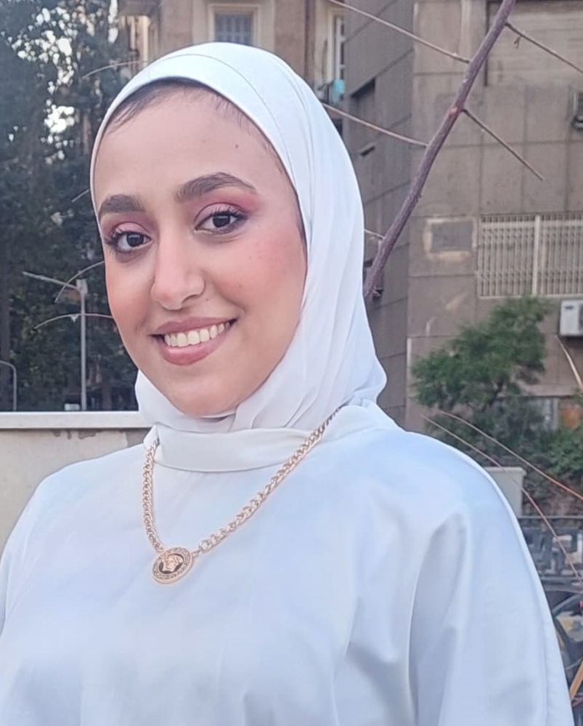
Esraa khalil Ahmed
Birth Date: 16-04-2000
Address: 14 Abdel Moneim Riad Street .Dar Al Salam. Cairo
Mobile: +20 115 010 7037
E-mail: Khalilesraa368@gmail.com

Career objectives

A challenging career opportunity that would give me the chance to be an effective member of an executive team in a successful international organization with global opportunities.

Education

- Ain shims Academy (ASA) Specialization in marketing and foreign trade.

Other skills

Languages | Reading | Writing | Speaking
Arabic | Excellent | Excellent | Excellent
English | Good | Good | Good

Computer Skills

Good working knowledge about these computer programs: MS Windows 9x; XP,MS Ohed e (2000,XP,2003),Internet Explorer.

Personal Profile
- Highly articulate and persuasive team-builder.
- Superlative Communication and Team-building Skills.
- Ability to manage multiple tasks in a pressured environment.
- Co-ordinate & Handle a variety of Administrative Tasks efficiently.

Work Experience
- Fresh graduate

Personal Data

Place of Birth : Cairo, Egypt
Nationality : Egyptian
Religion : Muslim
Marital status : Single

References

Furnished Upon Request,,

