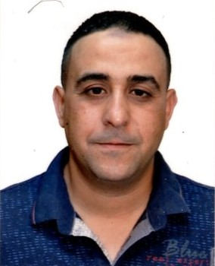

––

**DIPLOMAS Y HOBBIES**

**Formaciones :** Diplomados, Congresos, xxxxxxxxxx xxxxxx xxxxxxxxx xxxxxxxxxxxxxxxxx

**Hobbies:** xxxxxxxxxxxxxxxxxxxxxxxxxxxxxx



––

–––

**FORMATION**

* 2004 – 2007: Training Certificate in General Mechanics

Vocational Training Center of Moknine.

* 03/09/2007 – 15/07/2009: CAP DIPLOMA Doutile Machine Operator

CFPTI Moknine.

* 02/09/2009 – 15/07/2011: CONSTRUCTION DIPLOMA Technician in Manufacturing and Maintenance of Molds and Tools.

Sousse Plastics Training Center.

* 09/10/2015 – 09/10/2015: Participation in a G4 Mechanical Risks Training

Sancella Ksibet Mediouni Monastir Company

**Ahmed**

**Maatallah**

**Technician in Manufacture and Maintenance of Molds and Tools**

**LANGUAGES**

**Arabic: Mother Tongue**

**French: Intermediate**

**English: Intermediate**

Current Post :

**SKILLS**

**CONTACT**

Phone Number :

+(216) 24 388 356

Email : [**ahmedmatallah16@gmail.com**](mailto:ahmedmatallah16@gmail.com)

Residence:

Street Riadh Moknine 5050, Monastir

•Team work

• Management

•Crisis management

©AZURIUS – Modelos-de-curriculum.com

©AZURIUS – Modelos-de-curriculum.com

Sancella Ksibet Mediouni Monastir Compagny

13/12/2011- to date: Works as Maintenance

Technician & Spare Parts Manufacturing.

• Travel: Europe (France, Ireland and Spain), Asia (China, Japan, Thailand).

* Sport: Swimming, football, fencing.

**HOBBIES**