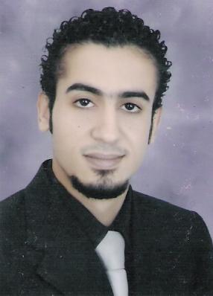

**Ahmed Abdelmonem Ali Elghazzawy**

**8st Trsa_Elharm_Giza_egypt**

**Tel :(02) 33883636**

**Mob :(012) 78297255**

**E-mail: Ahmedghazzawy@hotmail.com**

**Objective:**

**Seeking a challenging position in a multinational or a local organization**

**Where my educational background and skills can be applied and further developed in the field of accounting and sales.**

**Education:**

**May 2005_2006 Cairo University Egypt.**

**Faculty of commerce, accounting department.**

**Grade: fair.**

**Skills:**

**Computer skills:**

**. I have successfully trained on Microsoft office by Kseibi.**

**Information Technology ( KIT ).**

**. I take maintenance diploma by Kseibi information technology (KIT).**

**. I have successfully trained on ICDL.**

**Language skills:**

**. Native language Arabic.**

**. Very good command of both written and spoken English.**

**Experience:**

**. Worked in ( Crimca prima ) 6 month in account department in 2006.**

**. Worked in (united Brokerage ) Company 5 year, One year in Account department, Four year in customer service department (trader), Started worked in United Brokerage from 2007 to 2011 .**

**. Worked in Saudi Arabia for Seven years in Riyadh city, Six years in**

**(Cables World Company) in Account department, 4 years an Accountant,**

**2 years an Account Manager. Started worked in Cables World Company from 2012 to 2017 .**

**.Worked one year in (Fay United Real Estate Company) an Account Manager from 2017 to 2018 .**

**.Worked two years in ( Farid and his partner for plastic ) from November 2019 to October 2021 in Account Manager department .**

**Training:**

**. Sep2006_Dec2006 basic business skills Acquisition (BBSA) Cairo,   
 Egypt sponsors by the future generation foundation (FGF).**

**Developed language and computer skills, Enhanced presentation and project development skills, Acquired basic business skill including: marketing, sales, banking accounting, business correspondence and report writing.**

**. Work in contrast international company 2 month in sales department and**

**Have training for one month.**

**Interests:**

**Reading, searching in internet, traveling, football, watching movie and listening music.**

**Personal information:**

**Date of birth : 13/7/1984**

**Nationality : Egyptian**

**Marital status : Married**

**Military status : exempt**