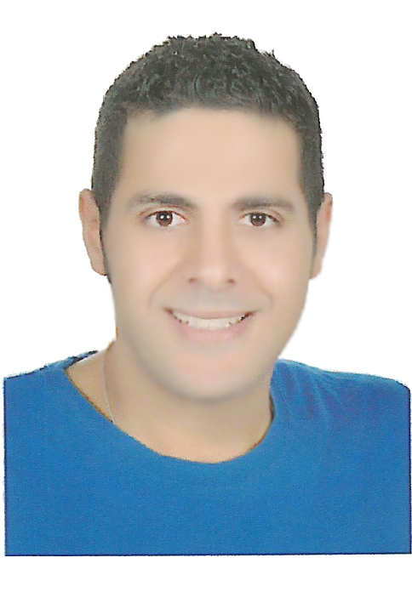

**CV**

**Mohamed Ashraf Abdel – Hamid Ahmed**

**52 Abdel Hakim Refaay st, Makram Obied , Nasr City, Cairo , Egypt**

**Mob: 01062757227 – 01129050000**

**E-mail:** [**zaza_mohmaed36@yahoo.com**](mailto:zaza_mohmaed36@yahoo.com)

**Personal data**

**Date of birth: 26-2-1992**

**Nationality: Egyptian**

**Marital status: Single**

**Military status: Exempted**

**Education & Qualification**

**Bachelor Mass of Communication – Cairo University – Open Education**

**General Dep. Grade: Good Year : 2015**

**Language Skills**

**Arabic: Mother Tongue English: Good**

**Computer Skills**

* MS Windows Internet
* ICDL from Start Academy

**Experience**

* Resonance imaging channel Sada El – Balad (6 months)
* Vodafone Customer Service Representative (6 months)
* Department of Imports Operations Evergreen Logistic Company   
  Public Relation & Sales (6 months)
* Sales Texmar Fabrics (6 months)
* Sales Royal Fabrics (4 months)
* Sales print shop Fabrics (6 months)
* Newspaper Journalist Egyptian Politics (1 Year)
* Announcer channel here Cairo (5 months)
* Worked with the Central Agency for Public Mobilization and Statistics (C.A.P.M.A.S) (1 Year)
* Administrative supervisor at the Russian Cultural Center (1 year)
* I worked in telephone sales at Media Egypt (6months)
* **Member of the General Union of Journalists, Printing and Publishing since 2016**
* **Coordinator at Subscriptions Department at Zamalek Sports Club (2017-2021)**
* **Executive Officer Coordinator in the Civil Status Department, 1st Nasr City PD  
  Ministry of Interior (2021-Present).**

**Training**

* Diploma in the field of Mass Media (International Academy of Consulting & Training) (2011)
* Diploma in ICDL &English Language & Human Development from Start Academy (2013)
* Diploma in Cambridge at the Institute called time (2015)