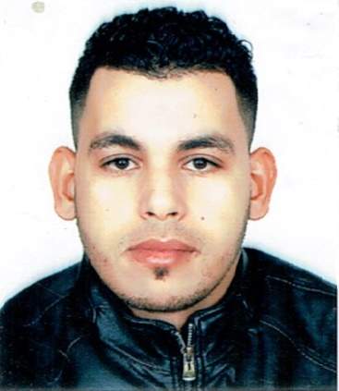

***BENLAASRI RACHID***

***Single / Moroccan***

***28 years***

**PROFESSIONAL EXPERIENCE**

* 09/08/2022 to 30/09/2022: Iberostar Founty Beach

Demi- Chef Party

* 01/12/2019 to 31/12/2021: Demi-chef left at the hotel

RIU TIKIDA PALACE in Taghazout in pastry.

* 02/01/2019 to 10/30/2019: Croissantier work within

the SAADA Pastry .

* From 03/04/2018 to 20/01/2019: Croissantier work

within the Pâtisserie la FONTAINE

* From 01/09/2017 to 30/03/2018: Internship at Hotel

TIKIDA DUNAS.

* 4 Months: Internship at Hotel TIKIDA BEACH

**OBJECTIVE**

Young Moroccan looking for an Internship or Job to improve my Skills for Your Organization

and also to ensure a good future

**TRAINING AND QUALIFICATIONS**

* 2017: Certificate of Regular Participation in the

First Aid Training Course organized by the

Moroccan Red Crescent Agadir

* 2016/2017: Bakery Pastry Technician Diploma at

ISTA FOUNTY.

* 2015/2016: Baccalaureate in Experimental

Science (SVT) at Lycée LALLA MARYEM Agadir.

* Driving license category (B).

**CONTACT**

²²²² >Q344

**benlaasrirachid@gmail.com**

* **06.18.87.28.18**
* **06.03.40.84.17**

**Street 240 № 60 Jorf Inezgane**



* 





* Microsoft Word.
* Excel.
* Power Point.
* Access.

**LANGUES**

* Arab : mother tangue
* Tamazight : mother tangue
* French : current level
* English : current level

**SKILLS**

* General accounting
* Financial analysis
* Production management
* Management control

**INTERESTS**

Internet

Reading

* Sport
* Travel
* Internet
* Reading

Travel س Internet