**Zi**

**ad**

**Mohamed Kamal**

**ElKafoury**

**Alexandria - EGYPT**

**▪**

**01004513077**

**▪**

**Date of birth :**

**23**

**/09/1997**

**Marital**

**Status**

**:**

**Single**

**Military Status :**

**Completed**

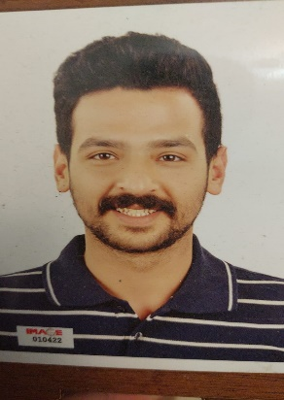

**Objective** Seeking a challenging position in a fast growing company where my academic background and interpersonal skills are well developed and utilized. And will give me the opportunity to make full use of my personal qualification and skills.

# Education

**Bachelors** 2020 University of Tanta,

Faculty of Commerce, English Section **Grade:** Very Good

# Experience

* Sales representative at Raya trade ( till now )
* Interface with other call centers, systems and departments as necessary to ensure proper handling of customer issues and concerns.
* Communicates and manages all performance objectives including technical support and customer service to ensure compliance with company philosophy and business goals.
* Looking into complaints and coordinating with clients to resolve their issues.
* Sales Agent at Silver Town Company for (1 Year).
* Former sales at Image for real estate investment for (1 Year).
* Trading Cars as a Free Lancing (Private Business).

**Course & Qualifications**

ICDL Courses (Self Learning).

# Skills & Abilities

* Ability to analyze problems and generate solutions.
* Possess excellent management and organizational skills.
* Confident, demonstrating a can do attitude and has a strong
* belief in their own ability to succeed.
* Self-motivated individual who is detail oriented and able to
* multi-task.
* Ability to prioritize individual workloads according to
* deadline

## Languages

**Arabic** (Native)

**English** (Very Good)