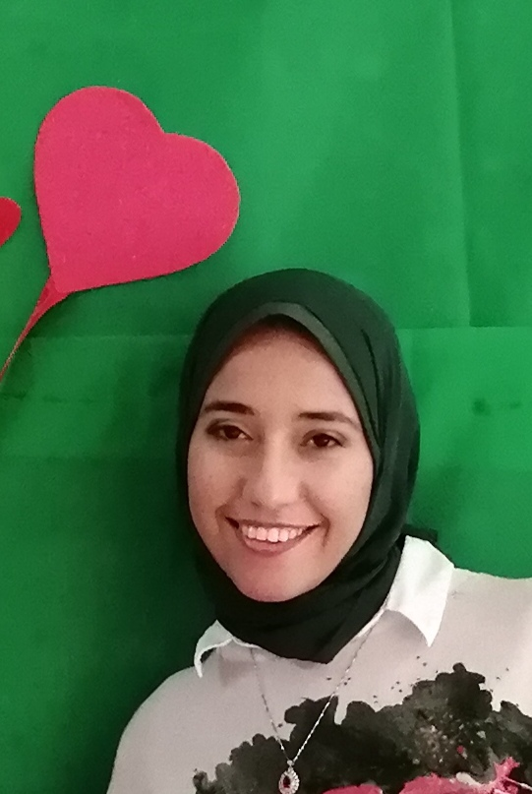

**Aya Mohamed Mohamed Kamal**

**Address: 239 D Gardinea - Ahmos Gate , Hadayek El Ahram**

**Mobile: 0106 77 139 20 - 01020522955**

**E-mail: aya.kamaleldeen@gmail.com**

**Career Objectives**

I am seeking to a position in a well-established organization where I can learn and enhance my skills

**Education**

* **(2013)** BSC of Commerce, Cairo University.
* **Major:** Accounting
* **grade:** Good

**Experience**

* **Admin Assistant at HF Fire** **International, Inc.**  **(Aug 2014)**

**Responsibilities:**

* Provide general office support and follow up on all administrative issues, Meetings.
* Coordinate with finance department, invoices issues, Collections Cheques.
* Receive incoming clients international and local Calls regarding any inquiries and Sending Faxes.
* **English teacher assistant at morooge nursery (2014)**
* **Administrator at Gulf Technical & Safety Training Centre ( GTSC )**

**(Sep 2015 till Feb 2016 )**

**Responsibilities:**

Ensuring co-ordinator and managing a professional standard of the following activities:

* To ensure that all filling system is according to IOS standards.
* Finalization of course implementation documents and all registration, nomination, enrollment, booking procedures, etc.
* To provide all assistance required by the training coordinator directly as per the guidelines and procedures provided.
* To work as per instructions and guidelines given by the general manager
* participates in monthly HSEQ meetings to discuss, promote and action related areas
* Promptly report all accidents and near misses
* in time reply to all clients inquiries and requests received by phone or email
* Proper preparation & handling of inquires , quotations, confirmations etc., through white board as guided by the training coordinator
* filling of all the documents of implemented course manual and on pc on time
* Forwarding to finance a monthly sheet including all expenses incurred during the month pertaining
* Forward course documents to the admin. dep. at the end of each course to process the invoice within 24 hours

* **Invigilator at British Council as part time from May 2017 till may 2021**
* **English teacher at timon and pumbaa nursery for ( preschool junior class) 2019 till 2021**

**Courses& Certificates**

* **TEFL Diploma accredited from AIPs. (Jan 2014 – March 2014)**
* **English Course in BERLITZ Center. 7 levels (May 2012-April 2013)**

Received the following topics and skills:

* Conversation
* General English
* Business English
* **Conversation English course (on Aug 2021)**
* **Human Resources course. (Oct 2010-Nov 2010)**

Received the following topics and skills:

* The Communication Skills.
* Marketing Skills.
* Creative Intelligence.
* Presentation Skills.
* **ICDL Certificate** (Powerpoint, Excel, Word, Access). **( 2010 - 2011 )**
* **Ergonomics Course from GTSC ( 15 Nov 2015 )**

**Skills**

* **Interpersonal Skills**
* Hard Worker.
* Positively Thinking.
* Patient, Ambitious.
* Good listener.
* Respect, help & appreciate others.
* **Language**
* Arabic: Mother tongue.
* English: Very good command of written and spoken

