

Nablus, zaita street

+972537216711

Nationality: Jordanian Marital Status: single

Weight: 75 kilo

Height: 185 cm

Age: 30

Education: Bachelor Degree in

Administrative and economic sciences

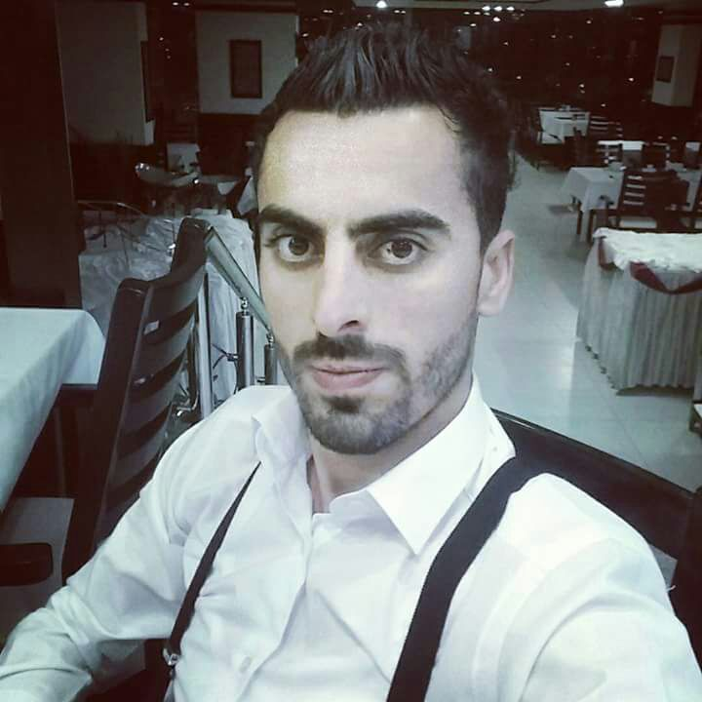

**Abdallah Mohammad Abdallah Ramadan**

**Automotive service advisor**



WORK EXPERIENCE

* **Restaurant manager: 10/07/2016-10/07/2017 in Nablus.**
* **Administrative at Al Najah National University hospital, Human Resources**

**Department.**

* **Automotive officer service booking at Emirates motor company Mercedes Benz**

**08/10/2017-08/10/2019.**



TRAINING COURSES AND PARTICIPTION

* **English conversation / an-najah university 29/10/2009 – 3/12/2009.**
* **Computer basics / at project hope 29/6/2011.**
* **First aid course / directorate of military medical services.**
* **Automotive access course / Mercedes Benz  (Autoline)2019.**

Abdallah.ramadan1609@gmail.com

* **Emirates motor company/Mercedes Benz participation:**

**1. Customer relationships.**

**2.Handling customer objections.**

**3.problem solving mentality.**

# 2019





CAREER OBJECTIVE

* **To attain a position in which my skills and experience will make a significant**

**contribution to an organization and will pose a challenge to my abilities**

**and provides an opportunity for a career growth.**

* **Seeking for a new opportunity to provide my services that would make use full of my knowledge and work experience and professional capabilities.**





SKILLS AND HIGHLIGHTS

* **Self-motivated person, hardworking and can work under**

**Pressure with minimum supervision.**

* **Physical strength to perform duties.**
* **Creative thinking skill.**
* **Patience.**
* **Able to pay attention to several tasks simultaneously with multi-tasking.**
* **Customer service oriented.**



KNOWLEDGE, SKILLS & ABILITIES

* **Educated & Well-Trained.**



* **Ability to work under pressure.**
* **Ability to take responsibility, seriousness, control and connectivity.**
* **Strong Communication & Interpersonal Skills.**
* **A Passion for Continuous Learning.**
* **Professionalism & Discipline.**
* **Ability to work with a computerized system.**
* **The conversation is in Arabic and English.**